**Cisco**

[**300-175**](https://www.marks4sure.com/300-175-exam.html)

**Implementing Cisco Data Center Unified Computing**

### Version: 15.1



Web: [www.marks4sure.com](https://www.marks4sure.com/) Email: [support@marks4sure.com](mailto:support@marks4sure.com)

### [ Total Questions: 331]

**IMPORTANT NOTICE**

# Feedback

We have developed quality product and state-of-art service to ensure our customers interest. If you have any suggestions, please feel free to contact us at [feedback@marks4sure.com](mailto:feedback@marks4sure.com)

# Support

If you have any questions about our product, please provide the following items: exam code



screenshot of the question login id/email

please contact us at [support@marks4sure.com](mailto:support@marks4sure.com) and our technical experts will provide support within 24 hours.

# Copyright

The product of each order has its own encryption code, so you should use it independently. Any unauthorized changes will inflict legal punishment. We reserve the right of final explanation for this statement.

Practice Test

Cisco - 300-175



### Exam Topic Breakdown

|  |  |
| --- | --- |
| **Exam Topic** | **Number of Questions** |
| Topic 1 : Main Set Questions | 131 |
| Topic 2 : Exam Set 1 | 93 |
| Topic 3 : Exam Set 2 | 107 |
| TOTAL | 331 |

Practice Test

Cisco - 300-175

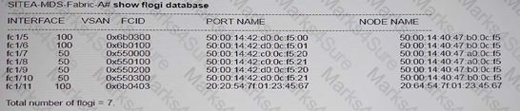

# Topic 1, Main Set Questions

Question #:1 - (Exam Topic 1)

A server discovery policy is defined in Cisco UCS Manager.

Which two actions are initiated by the policy when a new server starts? (Choose two.)

1. The qualification in the server discovery policy is executed against the server.
2. The scrub policy is applied to the server, if configured.
3. A service profile is created for the server with the identity burned into the server at time of manufacture.
4. The inventory of the server is analyzed.
5. The server is assigned to the selected organization, if configured.

### Answer: A D

Question #:2 - (Exam Topic 1)

You need to configure a Fibre Channel device alias named TEST for a device that is attached to port fc1./9 of a Cisco Nexus Series switch in a Cisco UCS system. Based on the output below, which command set should you use?

1. SITEA-MDS-Fabric-A# device-alias database

SITEA-MDS-Fabric-Fabric-A (device-alias-db)#device-alias name TEST pwwn 50:00:40:47:b0:0c:f5 SITEA-MDS—A (config-device-alias-db)# device-alias commit

1. SITEAA_MDS-Fabric-A# configure terminal

SITEA-MDS-Fabric-A (config)#device-alias database

SITEA-MDS-Fabric-A (config-device-alias-db)#device-alias nameTEST pwwn 50:00:14:40:47:b0:0c:f5 SITEA-MDS-Fabric-A (config-device-alias-db) device-alias commit

Practice Test

Cisco - 300-175

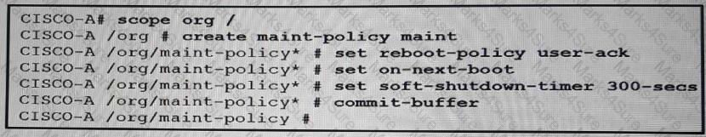

1. SITEA-MDS-Fabric-A#configure terminal

SITEA-MDS-Fabric-A (config-device-alias-db)# device-alias name TEST pwwn 50:00:14:42:do:0c:f5:20

SITEA-MDS-Fabric-A (config-device-alias-db)#device-alias commet

1. SITEA-MDS-Fabric-A# configure terminal

SITEA-MDS-Fabric-A (config)# device-alias database

SITEA-MDS-Fabric-A (config-device-alias-db)#device-alias name TEST pwwn 50:00:14:42:d0:oc:f5:20

SITEA-MDS-Fabric-A (config-device-alias-db)#exit

### Answer: D

Question #:3 - (Exam Topic 1)

Refer to the exhibit.

Which result of implementing the maintenance policy is true?

1. The FSM applies the waiting changes when the host OS resets.
2. The Cisco UCS server reboots as soon as the change is made to the service profile.
3. The Cisco UCS server reboots at a scheduled time.
4. The Cisco UCS server reboots 300 seconds after the policy is applied.

### Answer: A

Question #:4 - (Exam Topic 1)

Which two statements describe the full state type of backup? (Choose two.)

Practice Test

Cisco - 300-175



1. It is a binary file.
2. It cannot be used to restore the system during disaster recovery.
3. It can use this file for an import.
4. It can be used only on a system that is running the same version as the system from which the backup file was exported.
5. It is an XML file.

### Answer: A D

Question #:5 - (Exam Topic 1)

Which consideration must be made while performing backup operations within the Cisco UCS Manager?

1. Rerunning an existing backup operation overwrites the existing backup file.
2. Scheduled backups are not available.
3. A user can perform incremental backups of a system configuration.
4. Each backup destination can have multiple backup operations.

### Answer: A

Question #:6 - (Exam Topic 1)

A Cisco UCS Administrator is planning to complete a firmware upgrade using Auto install. Which two optionsare prerequisites to run Auto Install? (Choose two.)

1. Minor fault fixing
2. Configuration backup
3. Service profiles unmounted from the blade servers
4. Time synchronization
5. Fault suppression started on the blade servers

### Answer: B D

**Explanation**

Practice Test

Cisco - 300-175

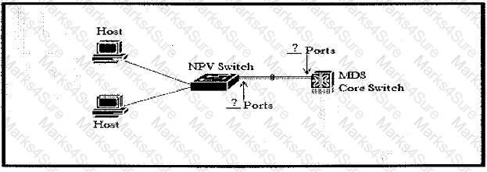

Explanation/Reference: Reference:

[https://www.cisco.com/c/en/us/td/docs/unified_computing/ucs/sw/firmware-mgmt/gui/2-2/b_GUI_Firmware_M](http://www.cisco.com/c/en/us/td/docs/unified_computing/ucs/sw/firmware-mgmt/gui/2-2/b_GUI_Firmware_M)

Question #:7 - (Exam Topic 1)

View the Exhibit.

Refer to the exhibit. An engineer is implementing a new network design that includes a port channel to connect an MDS core switch and an NPV switch.

Which two Fibre Channel port types must be used to create the Fibre Channel port channel? (Choose two.)

1. F Port
2. NP Port
3. NL Port
4. E Port
5. N Port
6. TL Port

### Answer: A B

Reference: [https://www.cisco.com/c/en/us/td/docs/switches/datacenter/mds9000/sw/4_1/configuration/guides/cli_4_1/clibo](http://www.cisco.com/c/en/us/td/docs/switches/datacenter/mds9000/sw/4_1/configuration/guides/cli_4_1/clibo)

Question #:8 - (Exam Topic 1)

Practice Test

Cisco - 300-175



You are creating service profiles for a Cisco UCS system by using the service profile wizard. You discover that you forgot to create the UUID pool.

What should you do?

1. From the wizard, click Create UUID Suffix Pool.
2. Pause the running wizard, and then start a temporary wizard to create a profile with the same name and the missing UUID pool. Resume the wizard, and then select the new UUID pool.
3. Continue running the wizard. The service profile uses the burned-in UUID in the BIOS of the server.
4. Stop the wizard, and then restart the wizard.

**Answer: A Explanation** Explanation Explanation/Reference:

Step 4

(Optional) If you want to create a new UUID Suffix pool to use in this service profile, click Create UUID Suffix

Pool and complete the fields in the Create UUID Suffix Pool wizard. For more information, see Creating a UUID Suffix Pool.

Reference:

[https://www.cisco.com/en/US/docs/unified_computing/ucs/sw/gui/config/guide/141/](http://www.cisco.com/en/US/docs/unified_computing/ucs/sw/gui/config/guide/141/) UCSM_GUI_Configuration_Guide_141_chapter24.html

Question #:9 - (Exam Topic 1)

When a configuration change requires a reboot, which policy specifies how Cisco UCS manager should proceed?

1. host firmware policy
2. local disk policy
3. maintenance policy
4. boot policy

### Answer: C

Practice Test

Cisco - 300-175



**Explanation** Explanation Explanation/Reference:

Use the Maintenance Policy to specify how Cisco UCS Manager should proceed for configuration changes that will have a service impact or require a server reboot. Values for the Maintenance Policy can be "immediate", "user- ack", or "timer automatic". The best practice is to not use the "default" policy, and instead to create and use Maintenance Policies for either "user- ack" or "timer automatic",

and to always have these as elements of the Service Profile or Service Profile Template definition.<http://www.cisco.com/c/en/us/products/collateral/>

servers-unified-computing/ucs-manager/whitepaper_c11-697337.html

Question #:10 - (Exam Topic 1)

Open the windows by clicking on the minimized title at the bottom of the viewing area. Windows can be minimized by clicking on the [-], repositioned by dragging the title bar, and resized by using the handle at the lower right corner to customize the viewing area.

If you are required to access the devices to complete this scenario, the mouse cursor will use a hand symbol when moved over device icons. Click the icon to open a device terminal to interact with the hardware.

Open the Questions window and begin with clicking a question number. When you have completed answering all questions, click Done to continue.

Scenario

Use your UCS knowledge on Fabric Interconnect Failover to answer the questions associated with the UCS cluster.

Exhibit.

Practice Test

Cisco - 300-175

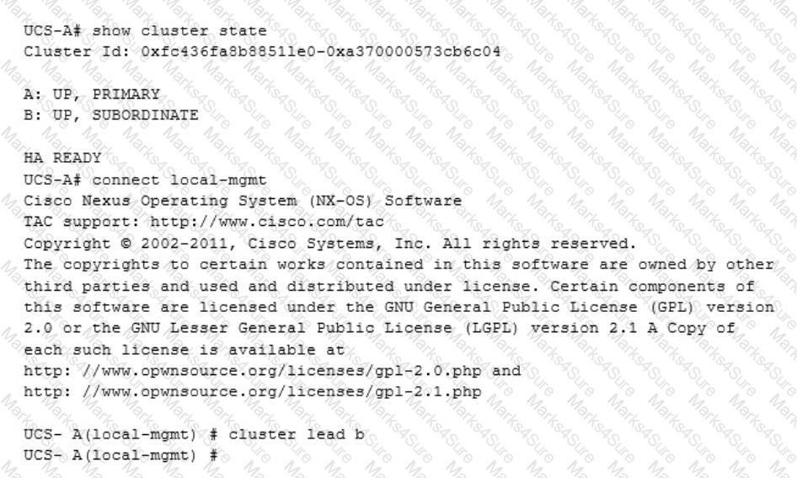

The cluster lead b command represents:

1. The cluster will go into a subordinate state.
2. The cluster will switch fabric interconnect b from subordinate to lead or primary.
3. The cluster will only use fabric interconnect to.
4. The cluster will load balance traffic over Fabric Interconnects a and b.

### Answer: B

Question #:11 - (Exam Topic 1)

A Cisco UCS Administrator is planning to complete a firmware upgrade using Auto install.

Practice Test

Cisco - 300-175



Which two options are prerequisites to run Auto install? (Choose two.)

1. minor fault fixing
2. configuration backup
3. service profiles unmounted from the blade servers
4. time synchronization
5. fault suppression started on the blade servers

### Answer: A B

Question #:12 - (Exam Topic 1)

Which two protocols does the Cisco Integrated Management Controller support for managing standalone Cisco UCS C-Series servers? (Choose two.)

1. SMASH CLP
2. IPMIv2
3. SoL
4. SNMPv3
5. Virtual KVM

**Answer: B D Explanation** Explanation/Reference:

[https://www.cisco.com/c/dam/en/us/products/collateral/servers-unified-computing/ucs-c-series-rack-servers/ata-](http://www.cisco.com/c/dam/en/us/products/collateral/servers-unified-computing/ucs-c-series-rack-servers/ata-)

The IMC supports industry-standard protocols, including Redfish version 1.01, Intelligent Platform Monitoring Interface Version 2 (IPMI v2), and Simple Network Management Protocol versions 2 and 3 (SNMP v2 and v3). It also provides an open Extensible Markup Language (XML) API and a command-line interface (CLI).

Question #:13 - (Exam Topic 1)

Open the windows by clicking on the minimized title at the bottom of the viewing area. Windows can be minimized by clicking on the [-], repositioned by dragging the title bar, and resized by using the handle at the lower right corner to customize the viewing area.

Practice Test

Cisco - 300-175

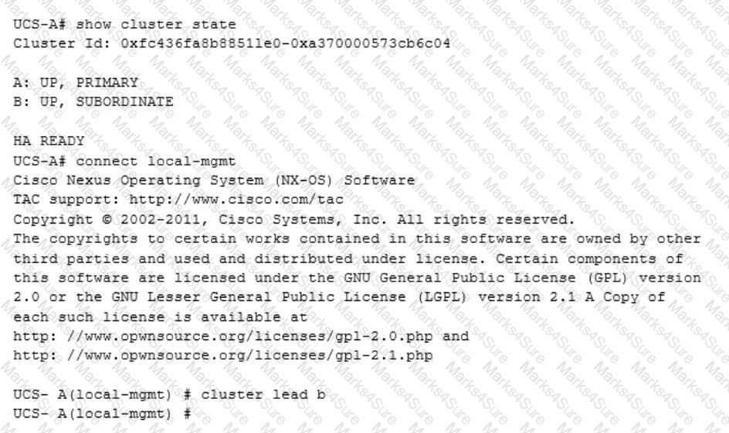

If you are required to access the devices to complete this scenario, the mouse cursor will use a hand symbol when moved over device icons. Click the icon to open a device terminal to interact with the hardware.

Open the Questions window and begin with clicking a question number. When you have completed answering all questions, click Done to continue.

Scenario

Use your UCS knowledge on Fabric Interconnect Failover to answer the questions associated with the UCS cluster.

Exhibit.

The connect local-mgmt command is required

1. To allow the fabric interconnect to use the force command to be subordinate.
2. To allow local management of the cluster to be configured.

Practice Test

Cisco - 300-175



1. To configure HA on all fabric interconnect.
2. To enable the fabric interconnect for a different HA state.

### Answer: B

Question #:14 - (Exam Topic 1)

An administrator is testing the Cisco Nexus 1000v switch on top of a Cisco UCS Blade. They realize that the test VM traffic is not marked correctly after it leaves the Cisco UCS B-series blade. What is the reason for seeing this behavior?

1. The Cisco UCS does not support QoS marking
2. The Cisco UCS QoS policy applied to the blade has the host control set to "none."
3. The Cisco Nexus 1000V Series Switches do not support QoS marking.
4. The Cisco Nexus 1000V Series Switch QoS marking has not been enabled with "feature gos."

**Answer: B Explanation** Explanation/Reference:

Whether UCS controls the CoS for a vNIC or not strictly depends on the Host Control Field of the QoS Policy, which is assigned to that particular vNIC.

If None is selected, then UCS assigns the CoS value associated with the Priority Class given in the QoS policy. It disregards any of the settings implemented at the host level by the Nexus 1000v.

If Full is selected and the packet has a valid CoS assigned by the Nexus 1000v, then UCS trusts the CoS settings assigned at the host level. Otherwise, Cisco UCS uses the CoS value associated with the priority selected in the Priority drop-down list.

The Milano QoS policy has a Host Control of Full, which means that the Gold Priority (CoS 6) is ignored and the Nexus 1000v setting is trusted.

The correct answer is "The Cisco UCS QoS policy applied to the blade has the host control set to "none." The other answers are not correct, or are not causes for the behavior.

Reference:

[https://www.cisco.com/c/en/us/support/docs/switches/nexus-1000v-switch/117541-configure-qos-00.html#anc6](http://www.cisco.com/c/en/us/support/docs/switches/nexus-1000v-switch/117541-configure-qos-00.html#anc6)

Question #:15 - (Exam Topic 1)

Practice Test

Cisco - 300-175



Which two statements are true concerning authorization when using RBAC in a Cisco Unified Computing System? (Choose two.)

1. A locale without any organizations, allows unrestricted access to system resources in all organizations.
2. When a user has both local and remote accounts, the roles defined in the remoteuser account override those in the local user account.
3. A role contains a set of privileges which define the operations that a user is allowed to take.
4. Customized roles can be configured on and downloaded from remote AAA servers.
5. The logical resources, pools and policies, are grouped into roles.

### Answer: C E

Question #:16 - (Exam Topic 1)

Which boot method would you use to boot the OS of a server by using a storage device located on an IP network?

1. CIMC secure boot
2. local disk boot
3. SAN boot
4. iSCSI boot

### Answer: D

Question #:17 - (Exam Topic 1)

You are implementing RBAC in Cisco UCS Manager. Which two statements about a locale are true? (Choose two.)

1. A locale without any organizations provides access to all organizations.
2. Each locale defines one to four organizations.
3. A user can be assigned to one or more locales.
4. Each locale defines one or more roles to which the user is allowed access.
5. There is a one-to-one relationship between a user and a locale.

### Answer: A C

Practice Test

Cisco - 300-175



Question #:18 - (Exam Topic 1)

Which two protocols are accepted by the Cisco UCS Manager XML API? (Choose two.)

1. SMASH
2. HTTPS
3. HTTP
4. XMTP
5. SNMP

**Answer: B C Explanation** Explanation/Reference:

The Cisco UCS Manager XML API is a programmatic interface to Cisco Unified Computing System (UCS). The API accepts XML documents through HTTP or HTTPS. Developers can use any programming language to generate XML documents that contain the API methods

Reference: [https://www.cisco.com/c/en/us/td/docs/unified_computing/ucs/sw/api/b_ucs_api_book/b_ucs_api_book_chapter](http://www.cisco.com/c/en/us/td/docs/unified_computing/ucs/sw/api/b_ucs_api_book/b_ucs_api_book_chapter)

Question #:19 - (Exam Topic 1)

Refer to the exhibit.

Practice Test

Cisco - 300-175

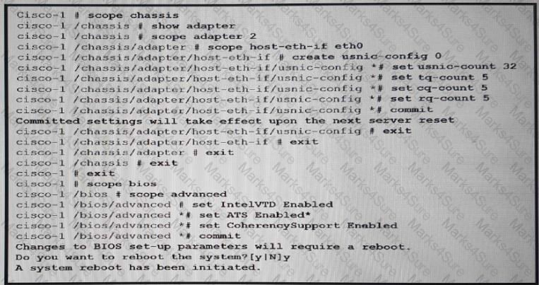

Which result of the configuration is true?

1. The usNIC replaces any vNICs in the server.
2. The kernel is bypassed when sending networking packets.
3. Device-specific DMA translations are cached on the fabric interconnect only
4. All network traffic goes to the OS kernel directly.

### Answer: A

Question #:20 - (Exam Topic 1)

Which Cisco UCS blade server supports the highest I/O throughput?

1. Cisco UCS B420 M3 Blade Server
2. Cisco UCS B200 M3 Blade Server
3. Cisco UCS B22 M3 Blade Server
4. Cisco UCS B200 M4 Blade Server

### Answer: A

Practice Test

Cisco - 300-175

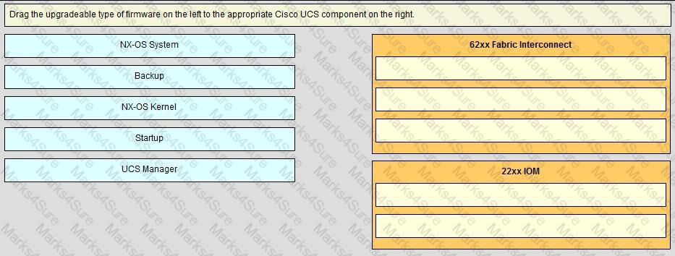

**Explanation** Explanation Explanation/Reference:

B420 M4 = 160G I/O BW

[https://www.cisco.com/c/en/us/products/collateral/servers-unified-computing/ucs-b-series-blade-servers/data_sh](http://www.cisco.com/c/en/us/products/collateral/servers-unified-computing/ucs-b-series-blade-servers/data_sh) [https://www.cisco.com/c/en/us/products/collateral/servers-unified-computing/ucs-b-series-blade-servers/data_sh](http://www.cisco.com/c/en/us/products/collateral/servers-unified-computing/ucs-b-series-blade-servers/data_sh) https://apps.cisco.com/ccw/cpc/guest/content/ucsModelDetails/model_b200m4 [https://www.cisco.com/c/en/us/products/collateral/servers-unified-computing/ucs-b200-m4-blade-server/datashe](http://www.cisco.com/c/en/us/products/collateral/servers-unified-computing/ucs-b200-m4-blade-server/datashe)

Question #:21 - (Exam Topic 1)

### Answer:

Practice Test

Cisco - 300-175

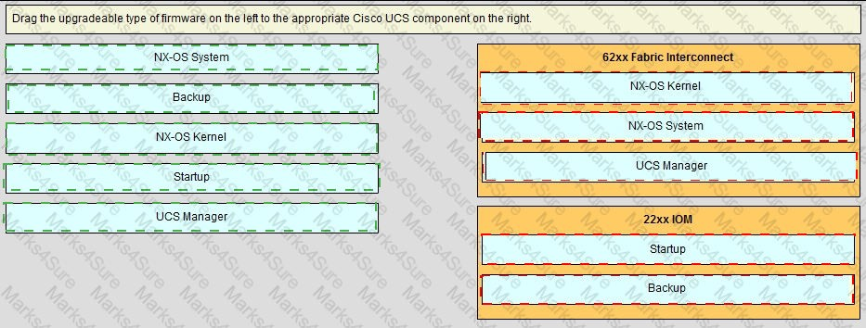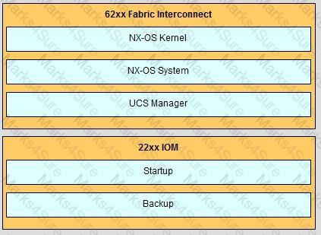

**Explanation**

Question #:22 - (Exam Topic 1)

Which two Cisco UCS C-Series server components are hot-swappable? (Choose two.)

1. mezzanine card
2. PCle slot
3. internal cooling fan

Practice Test

Cisco - 300-175



1. power supply
2. memory riser

### Answer: C D

Question #:23 - (Exam Topic 1)

Open the windows by clicking on the minimized at the bottom of the viewing area. Windows can be minimized by clicking on the [X], repositioned by dragging the title bar, and resized by using the handle at the lower right corner to customize the viewing area.

If you are required to access the devices to complete this scenario, the mouse cursor will use a hand symbol when moved over device icons. Clicking the icon will open a device terminal so you can interact with the hardware.

Open the Questions window and begin by clicking a question number. When you have completed answering all questions, click Done to continue.

Scenario

Use your UCS knowledge on Adapter errors ………………………………………configurations.

Practice Test

Cisco - 300-175

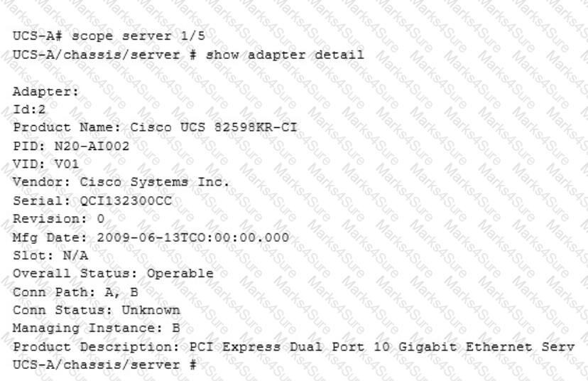

Current adapter status is?

1. Operable
2. Down
3. Inoperable
4. Unknown

### Answer: A

Question #:24 - (Exam Topic 1)

Practice Test

Cisco - 300-175

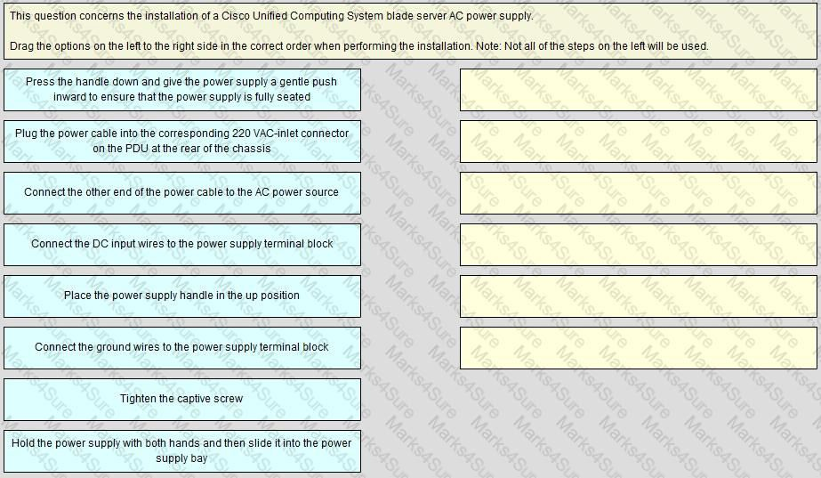

### Answer:

Practice Test

Cisco - 300-175

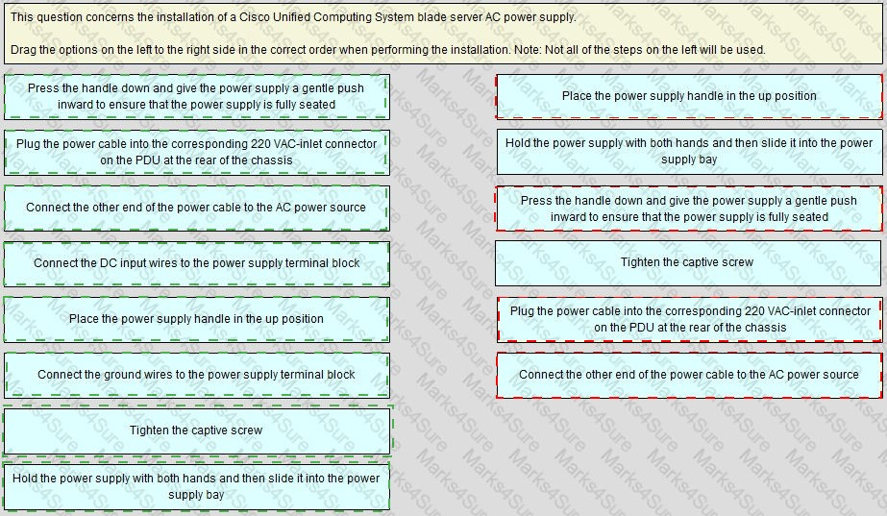

## Explanation

Practice Test

Cisco - 300-175

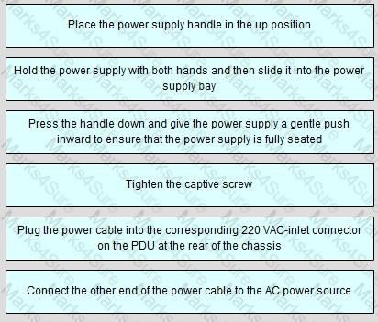

Question #:25 - (Exam Topic 1)

Which two statements about the service profile configuration options in the Cisco UCS Manager GUI are true? (Choose two.)

1. It can be generated automatically from the service profile template.
2. It can be derived from the chassis discovery policy.
3. It can be derived from the initial template or the updating template.
4. It can be configured by cloning a virtual machine profile.
5. It can be configured by using the chassis connectivity policy.

**Answer: A C Explanation** Explanation/Reference:

Reference: [https://www.cisco.com/en/US/docs/unified_computing/ucs/sw/gui/config/guide/141/UCSM_GUI_Configuration](http://www.cisco.com/en/US/docs/unified_computing/ucs/sw/gui/config/guide/141/UCSM_GUI_Configuration)

Question #:26 - (Exam Topic 1)

Refer to the exhibit.

Practice Test

Cisco - 300-175

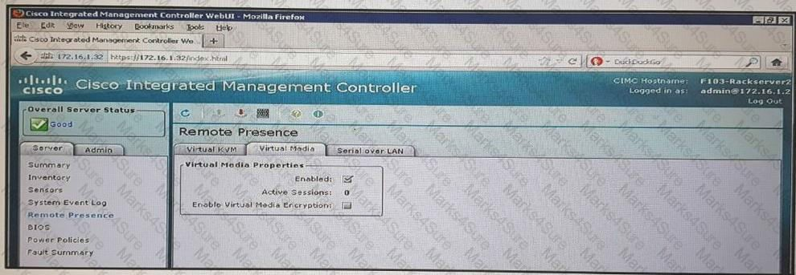

Which two media types can you mount from the KVM console? (Choose two.)

1. ISO
2. VHD
3. VHDx
4. IMG
5. VMDK

### Answer: A D

Question #:27 - (Exam Topic 1)

You are configuring service profiles for a Cisco UCS system. What are three types of logical resource pools? (Choose three.)

1. UUID
2. MAC
3. VLAN
4. WWN
5. VXLAN

Practice Test

Cisco - 300-175



1. FC

**Answer: A B D Explanation** Explanation Explanation/Reference: Reference:

[https://www.cisco.com/c/en/us/td/docs/unified_computing/ucs/sw/gui/config/guide/2-2/b_UCSM_GUI_Configu](http://www.cisco.com/c/en/us/td/docs/unified_computing/ucs/sw/gui/config/guide/2-2/b_UCSM_GUI_Configu) [https://www.safaribooksonline.com/library/view/ccna-data-center/9780133860429/ch15lev2sec3.html](http://www.safaribooksonline.com/library/view/ccna-data-center/9780133860429/ch15lev2sec3.html)

Question #:28 - (Exam Topic 1)

You need to automate the management of servers, networks, and storage on a Cisco UCS system, by using PowerShell.

Which tool should you use?

1. Cisco UCS Platform Emulator
2. Cisco UCS Python SDK
3. Cisco UCS Automation Tool
4. Cisco UCS PowerTool Suite

**Answer: D Explanation** Explanation Explanation/Reference: Reference:

[http://www.cisco.com/c/en/us/solutions/collateral/data-center-virtualization/microsoft-applications-on-ucs/broch](http://www.cisco.com/c/en/us/solutions/collateral/data-center-virtualization/microsoft-applications-on-ucs/brochure_c02-705764.html)

Question #:29 - (Exam Topic 1)

Refer to the exhibits.

Practice Test

Cisco - 300-175

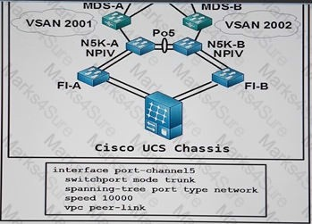

The blade server has two HBAs. How many WWPN targets on VSAN 2001 are accessible to the blade server?

1. 1
2. 2
3. 3
4. 4

### Answer: B

Question #:30 - (Exam Topic 1)

Which two are true concerning the role-based access control specifics of a Cisco Unified Computing System? (Choose two.)

1. Disabled local user accounts are deleted from the database.
2. A locally authenticated user account is any user account that is authenticated through LDAP, RADIUS, or TACACS+.
3. If a user maintains a local user account and a remote user account simultaneously, the roles that are defined in the local user account override those that are maintained in the remote user account.
4. By default, user accounts expire after 90 days; a warning message will be generated 10 days prior to expiration.
5. A user that is assigned one or more roles will be allowed the privileges that are consistent across all of the assigned roles.
6. All roles include read access to all configuration settings in the Cisco Unified Computing System domain.

Practice Test

Cisco - 300-175

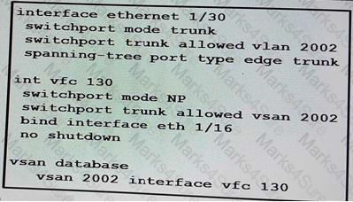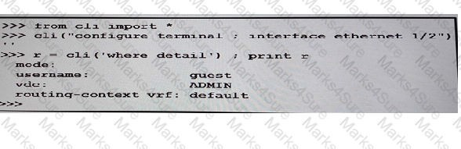

### Answer: C F

Question #:31 - (Exam Topic 1)

Refer to the exhibit.

Interface Ethernet 1/30 connects to which of switch?

1. a Fibre Channel switch that has NPV enabled
2. an FCoE switch that has NPV enabled
3. an FCoE switch that has NPV enabled
4. a Fibre Channel switch that has NPV enabled

### Answer: C

Question #:32 - (Exam Topic 1)

Refer to the exhibitwhich script ing tool do you use to create the script?

Practice Test

Cisco - 300-175

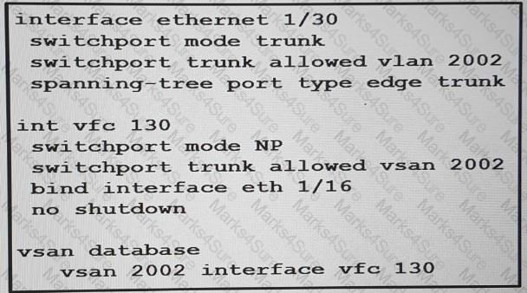

1. Python-API
2. Bach
3. NX-API
4. Broadcom shell

### Answer: A

Question #:33 - (Exam Topic 1)

Which option is a prerequisite when implementing iSCSI boot?

1. The OS must be iBFT compatible.
2. The boot parameters must be configured in the Global boot policy.
3. There are no licensing requirements for the storage array.
4. Each iSCSI initiator must be on the same IP subnet.

### Answer: A

Question #:34 - (Exam Topic 1)

Refer to the exhibit.

Practice Test

Cisco - 300-175



Interface Ethernet 1/30 connects to which type of switch?

1. an FCoE switch that has NPV enabled
2. a Fibre Channel switch that has NPV enabled
3. a Fibre Channel switch that has NPIV enabled
4. an FCoE switch that has NPIV enabled

### Answer: A

Question #:35 - (Exam Topic 1)

When configuring roles in the Cisco UCS C-Series, which role should be assigned for a person who must be allowed to power on the server and install a hypervisor using virtual media, but not allowed to configure other Cisco Integrated Management Controller settings?

1. VM admin
2. user
3. admin
4. read-only

### Answer: B

Question #:36 - (Exam Topic 1)

You have server that has a Cisco UCS CAN. A service profile that has a vNIC and a VHBA is mapped to fabric A. The vNIC is configured to use VLAN 10. VLAN 10 is the native VLAN for the vNIC. The vHBA is configured to use VSAN 2. Which description of the configuration is true?

1. VSAN 2 can be configured by using VLAN 10 as the FCoE VLAN ID.
2. VSAN 2 can read traffic on VLAN 5.
3. VLAN 10 and VSAN 2 must use the same ID.
4. VSAN 2 can be mapped to their VLANs in fabric A.

### Answer: A

Practice Test

Cisco - 300-175



Question #:37 - (Exam Topic 1)

In order to manually boot from the FlexFlash SD card, which boot option must be in the boot policy used in the service profile?

1. FlexFlash state
2. remote virtual drive
3. remote boot
4. SD card

### Answer: A

Question #:38 - (Exam Topic 1)

Which scripting tool encodes a CLI in the body of an HTTP post method?

1. Bash
2. NX-API
3. Broadcom Shell
4. Python-API

### Answer: B

Question #:39 - (Exam Topic 1)

Which of the following are true concerning authentication within a Cisco Unified Computing System?

1. Authentication domains are used to leverage individual authentication systems.
2. You can create up to 64 authentication domains, each associated with a provider group and realm in Cisco Unified Computing System Manager.
3. Cisco Unfiled Computing System supports LDAP or RADIUS for remote authentication.
4. A locally authenticated user account is authenticated directly through the fabric interconnect.

**Answer: D Explanation** Explanation/Reference:

Practice Test

Cisco - 300-175

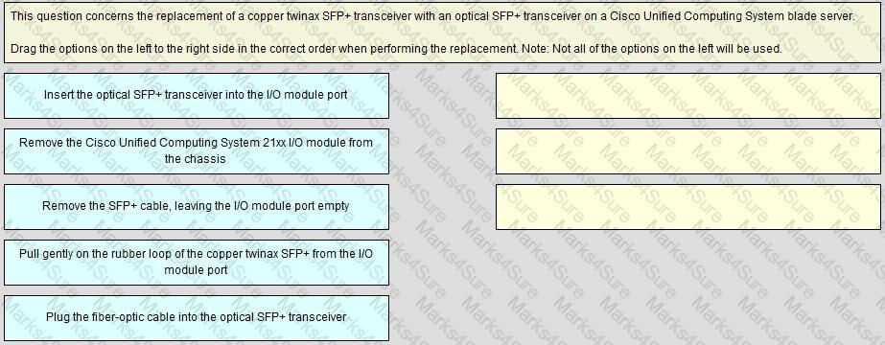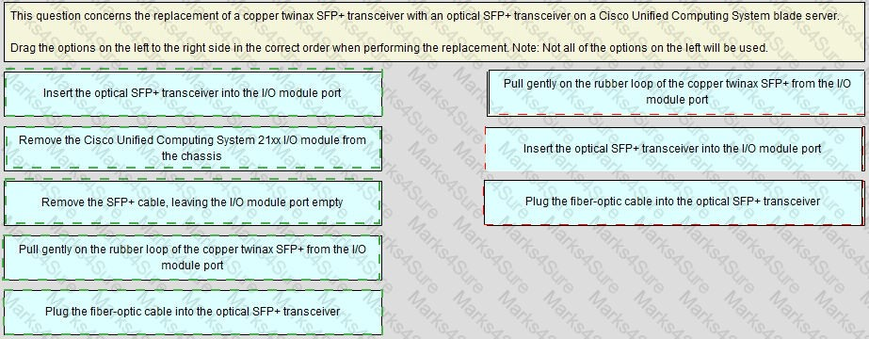

Reference:

[https://www.cisco.com/c/en/us/td/docs/unified_computing/ucs/sw/gui/config/guide/2-0/b_UCSM_GUI_Configu](http://www.cisco.com/c/en/us/td/docs/unified_computing/ucs/sw/gui/config/guide/2-0/b_UCSM_GUI_Configu)

Question #:40 - (Exam Topic 1)

### Answer:

Practice Test

Cisco - 300-175

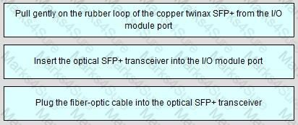

## Explanation

Question #:41 - (Exam Topic 1)

You configure FCoE in a Cisco UCS system at a customer site. The configuration seems correct, but the customer complains that the system fails to perform as expected. FCoE VLAN discovery, FCF discovery and FLOGI processes work properly. The issue appears to be with the Fibre Channel commands and responses.

What is a possible cause of the issue?

1. The storage device is experiencing configuration or compatibility issues when the FIP process completes successfully.
2. The routed Layer 3 network between the FCoE SAN and the storage device is experiencing issues when the FIP process fails to complete successfully.
3. The FCoE configuration is experiencing errors because of issues with the Fibre Channel commends.
4. The switched Layer 2 network between the FCoE SAN and the storage device is experiencing issues when the FIP process fails to complete successfully.

**Answer: D Explanation** Explanation Explanation/Reference:

Make sure that your native vlan is carried across all the trunk ports. Reference:

https://supportforums.cisco.com/t5/storage-networking/fip-and-native-vlan/td-p/2451783

Question #:42 - (Exam Topic 1)

Which two tasks can you perform from Cisco UCS Manager? (Choose two.)

Practice Test

Cisco - 300-175



1. Configure or manage external storage on the SAN.
2. Deploy an operating system.
3. Configure San PIN groupsS
4. Configure QoS classes and definitions.
5. Restart an Oracle database.

### Answer: C D

Question #:43 - (Exam Topic 1)

You plan to use AAA security services for a Cisco UCS Fabric Interconnect. Which two authentication protocols can you use? (Choose two.)

1. NTLM
2. Kerberos
3. RADIUS
4. Diameter
5. LDAP

**Answer: C E Explanation** Explanation Explanation/Reference:

Cisco UCS supports two methods to authenticate user logins:

Through user accounts local to Cisco UCS Manager. Remotely through one of the following protocols: LDAP

RADIUS TACACS+

Reference:

https://supportforums.cisco.com/t5/security-documents/ucs-fabric-intreconnect-integration-withacs-5-4-tacacs/ta

Practice Test

Cisco - 300-175



Question #:44 - (Exam Topic 1)

You need to install Cisco UCS Central Software at a customer site and set it up to manage Cisco UCS Manager.

What should you do to accomplish this goal?

1. Register the Cisco UCS domains in Cisco UCS Central Software.
2. Register the same Cisco UCS equipment that is managed by Cisco UCS Manager, and Cisco UCS Manager itself, in Cisco UCS Central Software.
3. Register Cisco UCS Manager in Cisco UCS Central Software.
4. Register Cisco UCS Central Software in Cisco UCS Manager.

### Answer: D

Question #:45 - (Exam Topic 1)

Which BIOS setting is required for a VMware ESXi 5.0 host to support Cisco VM-FEX universal pasthrough mode?

1. VT for Directed IO
2. ACPI 10 Support
3. VEMDPA Agent
4. Execute Disabled Bit
5. Processor C State

### Answer: A

Question #:46 - (Exam Topic 1)

You need to enable Cisco UCS Manager to support out-of-band IPv4 address access to the Cisco UCS KVM Direct launch page from a web browser.

What should you enable?

1. SMASH CLP
2. CIM XML
3. SNMP

Practice Test

Cisco - 300-175



1. CIMC Web Service

**Answer: D Explanation** Explanation/Reference:

-Cisco UCS Manager supports out-of-band IPv4 address access to the Cisco UCS KVM Direct launch page from a web browser. To provide this access, you must enable the following service: CIMC Web Service

[https://www.cisco.com/c/en/us/td/docs/unified_computing/ucs/sw/gui/config/guide/3-0/b_UCSM_GUI_User_G](http://www.cisco.com/c/en/us/td/docs/unified_computing/ucs/sw/gui/config/guide/3-0/b_UCSM_GUI_User_G)

Question #:47 - (Exam Topic 1)

You must update your certificates after the name of a Cisco UCS Fabric Interconnect cluster changes. Which action do you take?

1. Use the built-in default key ring certificate in Cisco UCS Manager.
2. Regenerate the certificate manually.
3. Request a new public-key certificate from the intermediate CA.
4. Request a new root certificate from the root CA.

### Answer: B

Question #:48 - (Exam Topic 1)

Which FEX connection mode do you use to pin the server-facing FEX ports to the connected uplink ports when the FEX is discovered?

1. port channel
2. soft pinning
3. hard pinning
4. vPC

### Answer: C

Question #:49 - (Exam Topic 1)

Practice Test

Cisco - 300-175



An administrator is required to configure a policy in Cisco UCS to schedule backups. Which two backup types can be scheduled? (Choose two.)

1. full state
2. import configuration
3. logical configuration
4. system configuration
5. all configuration

**Answer: A E Explanation** Explanation/Reference:

You can configure policies in Cisco UCS to schedule the following types of backups: Full state

All configuration

You cannot schedule any other type of backup. Full State Backup Policy

All Configuration Export Policy Reference:

[https://www.cisco.com/c/en/us/td/docs/unified_computing/ucs/sw/gui/config/guide/2-1/b_UCSM_GUI_Configu](http://www.cisco.com/c/en/us/td/docs/unified_computing/ucs/sw/gui/config/guide/2-1/b_UCSM_GUI_Configu)

Question #:50 - (Exam Topic 1)

You need to identify which DCB standard provides these functionalities: negotiation capabilities for features, the distribution of parameters from one node to another, and logical link up and down signaling for both Ethernet and Fibre Channel interfaces.

Which DCB standard should you identify?

1. ETS
2. PFC
3. DCBX

Practice Test

Cisco - 300-175



1. QCN

### Answer: C

Question #:51 - (Exam Topic 1)

Which item represents a secure method of transmitting fault data with Cisco Call Home?

1. Cisco Transport Gateway
2. RSA Digital Certificate
3. IPsec
4. secure XML

### Answer: A

Question #:52 - (Exam Topic 1)

Which two prerequisites are required to configure a SAN boot from the FCoE storage of a Cisco UCS system? (Choose two.)

1. The Cisco UCS domain must be able to communicate with the SAN storage device that hosts the operating system image.
2. A boot policy must he created that contains a local disk, and the LVM must be configured correctly.
3. There must be IVR-enabled FCoEproxying between the Cisco UCS domain and the SAN storage device that hosts the operating system image.
4. There must be a boot target LUN on the device where the operating system image is located.
5. There must be a boot target RAID on the device where the operating system image is located.

### Answer: D E

Question #:53 - (Exam Topic 1)

You need to install a Windows Server operating system that has MPIO enabled, to optimize connectivity with storage arrays.

What is a valid prerequisite to perform this task?

1. iSCSImultipathing must be enabled on all of the vNICs and the physical adapters in the iSCSI initiator

Practice Test

Cisco - 300-175

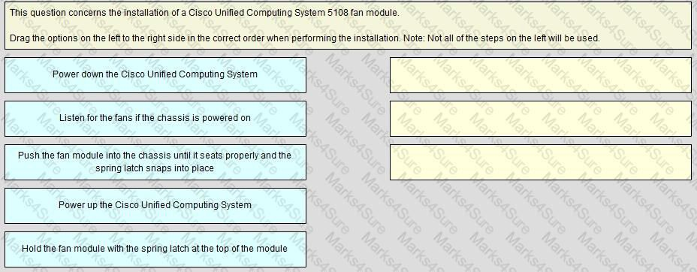

IP pools.

1. iSCSImultipathing must be disabled during the installation and re-enabled after MPIO is enabled on the host.
2. If there are multiple paths that are configured to the boot LUN, all of these paths must be enabled when the LUN is installed.
3. If there are multiple paths that are configured to the boot LUN, only one path must be enabled when the LUN is installed.

**Answer: D Explanation** Explanation/Reference:

If there are multiple paths configured to the boot LUN, only one path should be enabled when the LUN is installed

Reference:

[https://www.cisco.com/c/en/us/td/docs/unified_computing/ucs/sw/gui/config/guide/2-2/b_UCSM_GUI_Configu](http://www.cisco.com/c/en/us/td/docs/unified_computing/ucs/sw/gui/config/guide/2-2/b_UCSM_GUI_Configu)

Question #:54 - (Exam Topic 1)

### Answer:

Practice Test

Cisco - 300-175

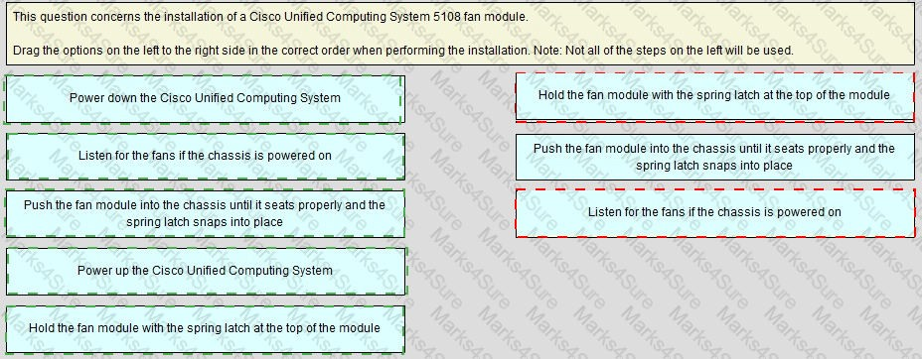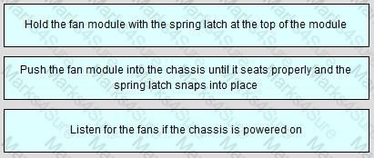

## Explanation

Question #:55 - (Exam Topic 1)

You need to implement a Cisco UCS system at a customer Site.

Which adapters and operating systems have preprovisioned adapter policies?

1. Ethernet vNICs and Windows, OS X Server. and Oracle Solaris operating systems.
2. Fibre Channel vNICs and Windows, FreeBSD, and Linux Operating systems.
3. Ethernet vNICs and Windows, VMware, and Linux operating systems.
4. Fibre Channel vNICs and Windows, Oracle Solaris, and Linux operating systems.

### Answer: D

Practice Test

Cisco - 300-175



Reference:

<http://www.educationalcentre.co.uk/deploy-a-cisco-ucs-system-part-2-from-scratch-for-vmware-esxi/> [https://www.cisco.com/c/en/us/td/docs/unified_computing/ucs/sw/gui/config/guide/2-2/b_UCSM_GUI_Configu](http://www.cisco.com/c/en/us/td/docs/unified_computing/ucs/sw/gui/config/guide/2-2/b_UCSM_GUI_Configu)

Question #:56 - (Exam Topic 1)

Open the windows by clicking on the minimized at the bottom of the viewing area. Windows can be minimized by clicking on the [X], repositioned by dragging the title bar, and resized by using the handle at the lower right corner to customize the viewing area.

If you are required to access the devices to complete this scenario, the mouse cursor will use a hand symbol when moved over device icons. Clicking the icon will open a device terminal so you can interact with the hardware.

Open the Questions window and begin by clicking a question number. When you have completed answering all questions, click Done to continue.

Scenario

Use your UCS knowledge on Adapter errors ………………………………………configurations.

Practice Test

Cisco - 300-175

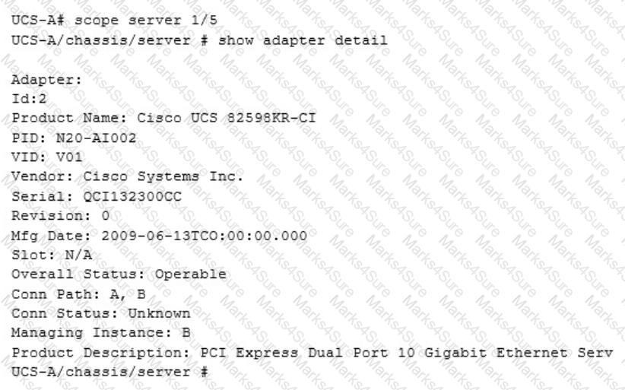

We are working on which Chassis ID?

1. 1
2. 2
3. 3
4. 4
5. 5

### Answer: A

Question #:57 - (Exam Topic 1)

What is the Overlay Transport Virtualization site VLAN used for?

1. to allow multiple site AEDs to communicate with each other

Practice Test

Cisco - 300-175

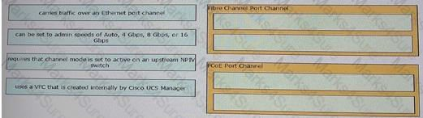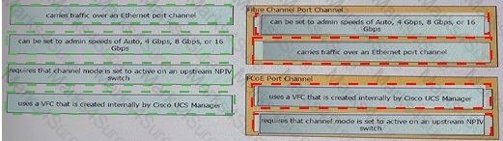

1. to detect devices at the site that are not capable of OTV
2. to facilitate communications between OTV edge devices within the site
3. to allow the join interfaces at different sites to communicate

### Answer: C

Question #:58 - (Exam Topic 1)

You are configuring a Cisco UCS port channel. Drag and drop the description from the left onto the correct port channel types on the right.

### Answer:

Question #:59 - (Exam Topic 1)

Which two options does the Cisco Integrated Management Controller support for managing standalone Cisco UCS C-Series servers? (Choose two.)

1. SoL
2. XML
3. SSH
4. Virtual KVM
5. SMASH CLP

Practice Test

Cisco - 300-175



### Answer: B C

Question #:60 - (Exam Topic 1)

Which two prerequisites are required to configure a SAN boot from the iSCSI storage of a Cisco UCS system? (Choose two.)

1. There must be FCIP connectivity between the Cisco UCS domain and the boot target storage.
2. There must be IP connectivity between the Cisco UCS domain and the boot target storage.
3. The operating system to boot must be iBFT-capable.
4. There must be a group of IP addresses that is associated with the WWN pool.
5. The operating system to boot must be an iSCSI initiator and must he target-capable.

**Answer: C E Explanation** Explanation/Reference:

To use a SAN boot, ensure that the following is configured: The Cisco UCS domain must be able to communicate with the SAN storage device that hosts the operating system image.

The next step, which is the installation of the operating system (OS), requires an OS that is iBFT capable.

There must be FCIP connectivity between the Cisco UCS domain and the boot target storage. NOT CORRECT (FCIP IS FC).

There must be IP connectivity between the Cisco UCS domain and the boot target storage. CORRECT The operating system to boot must be iBFT-capable. CORRECT.

There must be a group of IP addresses that is associated with the WWN pool. NOT CORRECT (WWN IS FC).

The operating system to boot must be an iSCSI initiator and must be target-capable. MAYBE. Reference:

[https://www.cisco.com/c/en/us/td/docs/unified_computing/ucs/sw/gui/config/guide/2-0/b_UCSM_GUI_Configu](http://www.cisco.com/c/en/us/td/docs/unified_computing/ucs/sw/gui/config/guide/2-0/b_UCSM_GUI_Configu)

Question #:61 - (Exam Topic 1)

Which actions must be taken in order to connect a NetAppFCoE storage system to a Cisco UCS system?

1. Ensure that the Fibre Channel switching mode is set to Switching, and use the Fibre Channel ports on

Practice Test

Cisco - 300-175



the Fabric Interconnects.

1. Ensure that the Fibre Channel switching mode is set to Switching, and reconfigure the port to aFCoE Storage port.
2. Ensure that the Fibre Channel switching mode is set to End-Host, and use the Ethernet ports on the Fabric Interconnects.
3. Ensure that the Fibre Channel switching mode is set to Switching, and use the Ethernet ports on the Fabric Interconnects.

**Answer: B Explanation** Explanation/Reference: References:

<http://www.renar.net/?p=148>&lang=en [https://www.cisco.com/c/en/us/td/docs/unified_computing/ucs/release/notes/UCS_28313.html](http://www.cisco.com/c/en/us/td/docs/unified_computing/ucs/release/notes/UCS_28313.html)

Question #:62 - (Exam Topic 1)

You need to configure a new Fibre Channel port channel from the Cisco UCS Manager GUI. To do this, from the SAN tab, you navigate to SAN Cloud > Fabric A or B > FC Port Channels, and you click the plus sign. In the popup window, you specify the Fibre Channel port channel name and ID.

Which two rules should you follow when you set the Fibre Channel port channel name and ID? (Choose two.)

1. The Name field must be a number.
2. The ID field can contain ASCII characters, except for spaces.
3. The Name field is optional, but it cannot contain spaces.
4. TheFibre Channel port channel ID is optional.
5. TheFibre Channel port channel ID must be a number.

**Answer: C E Explanation** Explanation Explanation/Reference:

The identifier for the port channel.

Practice Test

Cisco - 300-175



Enter an integer between 1 and 256. This ID cannot be changed after the port channel has been saved. Name field A user-defined name for the port channel.

This name can be between 1 and 16 alphanumeric characters. You cannot use spaces or any special characters other than - (hyphen), _ (underscore), : (colon), and . (period), and you cannot change this name after the object has been saved.

The Fibre Channel port channel ID is NOT optional

The ID field CANNOT contain ASCII characters, OR spaces. The Name field must be a number IS NOT CORRECT.

The Fibre Channel port channel ID must be a number. IS CORRECT The Name field is optional, but it cannot contain spaces. IS CORRECT

The name field is optional (notice the "Next >" button is available when the name field is empty.

Question #:63 - (Exam Topic 1)

After an admin configures a service profile template and associates it to the blade, the admin notices that changes to the template are not automatically pushed to profiles that are inheriting that template. The service profile template and vNIC templates are set to "initial".

Which two actions resolve this issue? (Choose two.)

1. Delete the vNIC template and re-create it as an updating template.
2. Change the type of the service profile template from "initial" to "updating".
3. Delete the service profile template and re-create it as an updating template.
4. Delete and recreate all templates.
5. Change the type of the vNIC template from "initial" to "updating".

### Answer: C E

Question #:64 - (Exam Topic 1)

Refer to the exhibit.

Which option is the expected outcome on the configured switch?

Practice Test

Cisco - 300-175



1. The switch enforces SNMP message encryption for the user all.
2. SNMP requires encryption for all incoming requests.
3. The switch enforces SNMP message encryption for all users.
4. The switch responds with an authorization error for any SNMPv3 PDU requests that use a security level parameter of authNoPriv.

### Answer: C

Question #:65 - (Exam Topic 1)

You need to identify which DCB standard provides those functionalities negotiation capabilities for features, the distribution of parameters from one node to another, and logical link up and down signaling for both Ethernet and fibre Channel interfaces. Which DCB standard should you identity?

1. ETS
2. PFC
3. DCBX
4. QCN

**Answer: C Explanation** Explanation/Reference: Reference:

[https://www.cisco.com/c/dam/en/us/solutions/collateral/data-center-virtualization/ieee-802-1-data-centerbridgin](http://www.cisco.com/c/dam/en/us/solutions/collateral/data-center-virtualization/ieee-802-1-data-centerbridgin) [https://www.cisco.com/c/dam/en/us/products/collateral/storage-networking/mds-9700-series-multilayerdirectors](http://www.cisco.com/c/dam/en/us/products/collateral/storage-networking/mds-9700-series-multilayerdirectors)

Question #:66 - (Exam Topic 1)

A network administrator has configured all required settings for the Smart Call Home feature in Cisco UCS. What must be done next?

1. Open a TAC case to verify contract information and start the registration process.
2. Generate a fault to initiate a message that will start the registration process.
3. The system automatically starts the registration process and no further action is required.

Practice Test

Cisco - 300-175

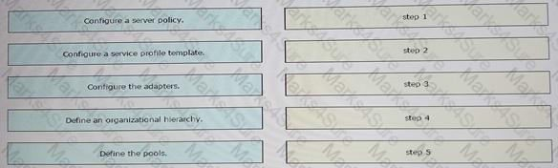

1. Send a system inventory message to start the registration process.

### Answer: D

Question #:67 - (Exam Topic 1)

You need to configure service profiles for a Cisco UCS system.

What is an advantage of using the Expert wizard to create the service profiles instead of using the Simple wizard?

1. Only the Expert wizard supports Fabric Interconnect expansion module ports to beused in 10-Gigabit uplink mode or Fibre Channel mode.
2. Both wizards support the same features, but the Expert wizard provides no configuration options for the features.
3. The Expert wizard supports stateless computing and mobile service profiles.
4. The Expert wizard supports all blade generations, whereas the Simple wizard supports only M1 blades, M2 blades, and Cisco VIC cards.

### Answer: B

Question #:68 - (Exam Topic 1)

You must define a workload using Cisco UCS Manager. Drag and drop the workload definition tasks from the left into the correct order on the right.

### Answer:

Practice Test

Cisco - 300-175

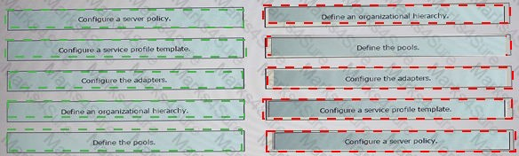

## Explanation

Define organizational hierarchy Define Pools

Configure Adapters

Configure Service Profile Templates Configure Server Policies

Question #:69 - (Exam Topic 1)

Which statement is true regarding backup operations in Cisco UCS Manager?

1. A user can perform incremental backups of a system configuration.
2. Passwords and other sensitive information are encrypted in full state backups.
3. Scheduled backups are not available.
4. Each backup destination can have multiple backup operations.

### Answer: B

Question #:70 - (Exam Topic 1)

Drag and drop the scripting tools on the left to the correct definitions on the right.

Practice Test

Cisco - 300-175

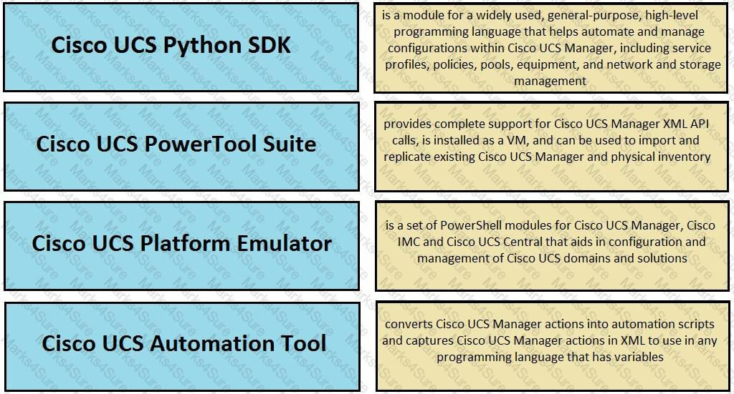

### Answer:

Practice Test

Cisco - 300-175

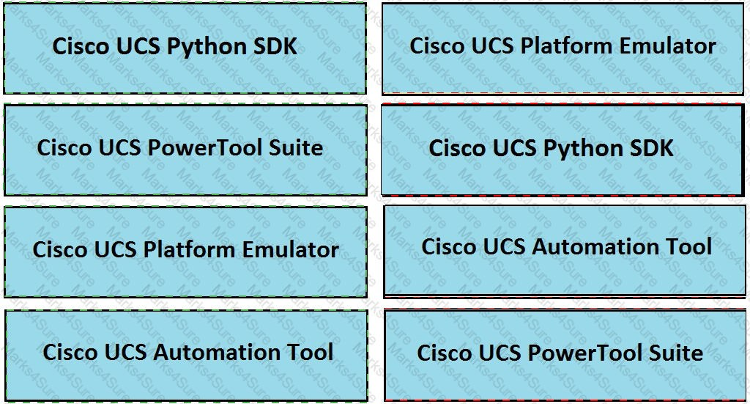

## Explanation

Cisco UCS Python SDK

(provides complete suppport for cisco ucs manager XML PAI calls,is installed as a Vm,and can be used to import and replicate existing cisco ucs manager and physical inventory )

Cisco UCS Platform Emulator

(is a module for widely used,general-purpose,high-level programming language that helps automate and manage configuration within cisco ucs manager ,including service profiles,policies ,pools,equipment,am=nd network and storage management)

Cisco UCS Automation Tool

(converts Cisco UCS Manager actions into automation scripts and captures Cisco UCS Manager actions in XML to use in any programming language that has variables )

Cisco UCS PowerTool Suite

Practice Test

Cisco - 300-175

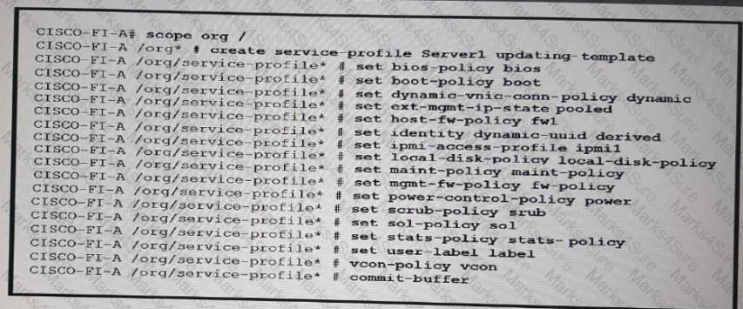

(is a set of Powershell modules for cisco ucsmanager,cisco IMC and cisco ucs Central that aids in configuration and management of cisco ucs domains and solutions )

Question #:71 - (Exam Topic 1)

Which addressing does Cisco UCS Manager use when communicating with Cisco UCS Central?

1. IP addresses of the UCS Fabric Interconnects
2. UCS CIMC
3. VMware ESXi server
4. IP address of the UCS KVM

### Answer: A

Question #:72 - (Exam Topic 1)

Refer to the exhibit.

How does a server acquire a UUID?

1. from the UUID burned into the hardware
2. from a UUID pool named derived

Practice Test

Cisco - 300-175



1. manually by a user when the server boots
2. by padding the MAC address with leading zeros

### Answer: A

Question #:73 - (Exam Topic 1)

Which solution enables Cisco devices to be monitored with automated support capabilities?

1. Cisco Intelligent Monitoring Agent
2. Smart Call Home
3. Smart Bonding Service
4. Connected Service Assurance

### Answer: B

Question #:74 - (Exam Topic 1)

You plan to configure a Fibre Channel port channel on a Cisco UCS system.

What is the maximum number of port channels and ports per port channel on a Cisco UCS 6200 Series device?

1. fourFibre Channel port channels and 24 Fibre Channel ports per port channel
2. eightFibre Channel port channels and 24 Fibre Channel ports per port channel
3. eightFibre Channel port channels and 16 Fibre Channel ports per port channel
4. fourFibre Channel port channels and 16 Fibre Channel ports per port channel

**Answer: D Explanation** Explanation/Reference: Reference:

[https://www.cisco.com/c/en/us/td/docs/unified_computing/ucs/sw/configuration_limits/2-0/b_UCS_Configurati](http://www.cisco.com/c/en/us/td/docs/unified_computing/ucs/sw/configuration_limits/2-0/b_UCS_Configurati)

Question #:75 - (Exam Topic 1)

Practice Test

Cisco - 300-175



In Cisco UCS Manager 2.2 or later, in order to manually boot from the FlexFlash SD card, which boot option must be in the boot policy used in the service profile?

1. remote virtual drive
2. FlexFlash state
3. SD card
4. remote boot

### Answer: B

Question #:76 - (Exam Topic 1)

You must implement a Dynamic FCoE topology that uses ECMP. Which ancillary technology do you use?

1. OTV
2. VXLAN
3. FabricPath
4. EIGRP

### Answer: C

Question #:77 - (Exam Topic 1)

View the Exhibit.

Practice Test

Cisco - 300-175

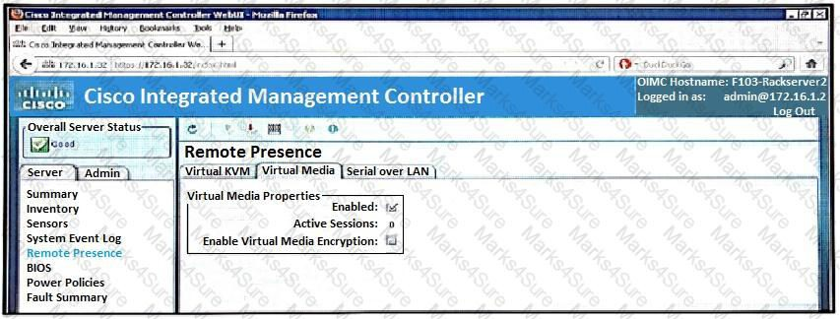

Refer to the exhibit. Which two media types can you mount from the KVM console? (Choose two.)

1. VHD
2. ISO
3. VMDK
4. IMG
5. VHDx

**Answer: B D Explanation** Explanation/Reference:

[https://www.cisco.com/en/US/docs/unified_computing/ucs/sw/gui/config/guide/141/UCSM_GUI_Configuration](http://www.cisco.com/en/US/docs/unified_computing/ucs/sw/gui/config/guide/141/UCSM_GUI_Configuration) 4

"Opens the Open dialog box that lets you navigate to the ISO or IMG file you want to the server to access."

Question #:78 - (Exam Topic 1)

To boot from SAN, you must perform which two configurations on a Cisco UCS system? (Choose two.)

1. Enter the boot LUN and the nWWNs.
2. Put the boot VSANin a dedicated boot service profile template.

Practice Test

Cisco - 300-175



1. Create a LUN, and allow the server WWPN to have access to the LUN.
2. Put the server WWPN and the storage array WWPN in the same zone.
3. Create a dedicated boot VSAN.

**Answer: C D Explanation** Explanation Explanation/Reference: Reference:

<http://jeffsaidso.com/2010/11/boot-from-san-101-with-cisco-ucs>

Question #:79 - (Exam Topic 1)

Which Cisco UCS backup type results in an XML file that include all system and logical configuration settings?

1. system configuration
2. all configuration
3. full state
4. logical configuration

### Answer: A

Question #:80 - (Exam Topic 1)

You need to provision iSCSI initiator IP pools on a Cisco UCS system. How many iSCSIvNICs can you use per boot policy?

1. 2
2. 4
3. 6
4. 8

### Answer: A

Practice Test

Cisco - 300-175



**Explanation** Explanation Explanation/Reference:

You can add up to two iSCSIvNICs per boot policy. One vNIC acts as the primary iSCSI boot source, and the other acts as the secondary iSCSI boot source.

Reference:

[https://www.cisco.com/c/en/us/td/docs/unified_computing/ucs/sw/gui/config/guide/2-2/b_UCSM_GUI_Configu](http://www.cisco.com/c/en/us/td/docs/unified_computing/ucs/sw/gui/config/guide/2-2/b_UCSM_GUI_Configu)

Question #:81 - (Exam Topic 1)

Which destination(s) are valid for syslog messages for a Cisco UCS Fabric Interconnect?

1. the log, the monitor and syslog queue
2. a file
3. the console and log only
4. the console, the monitor, and a file

**Answer: D Explanation** Explanation Explanation/Reference:

[http://www.cisco.com/c/en/us/td/docs/unified_computing/ucs/sw/ucsm_syslog/b_Monitoring_Cisco_UCSM_Us](http://www.cisco.com/c/en/us/td/docs/unified_computing/ucs/sw/ucsm_syslog/b_Monitoring_Cisco_UCSM_Using_Syslog/b_Monitoring_Cisco_UCSM_Using_Syslog_chapter_010.html)

Question #:82 - (Exam Topic 1)

You plan to configure a SAN boot from the iSCSI storage of a Cisco UCS system. Which statement about an iSCSIvNIC is true?

1. All iSCSI data traffic is carried over the vNIC after the boot.
2. An iSCSIvNIC is an iBFT configuration placeholder for the iSCSI boot configuration. The vNIC exists only during the startup phase.
3. Only iSCSI control date traffic is carried over the vNIC after the boot.

Practice Test

Cisco - 300-175

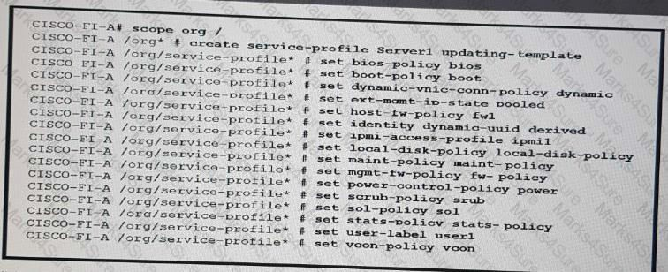

1. An iSCSIvNIC is an iBFT configuration placeholder for the iSCSI boot process. The vNIC exists during and after the startup phase.

### Answer: A

Question #:83 - (Exam Topic 1)

Refer to the exhibit.

You bind the service profile to the updating template. You plan to update the template. Which impact on the service profile when you update the template is true?

1. Changes to the service profile are locked after the profile is created.
2. The update to the service profile fails.
3. The service profile must be updated manually.
4. The service profile is updated automatically.

### Answer: A

Question #:84 - (Exam Topic 1)

In an environment where multiple LDAP servers are used for user authentication, which Cisco UCS Manager feature must be configured?

1. LDAP Locale

Practice Test

Cisco - 300-175

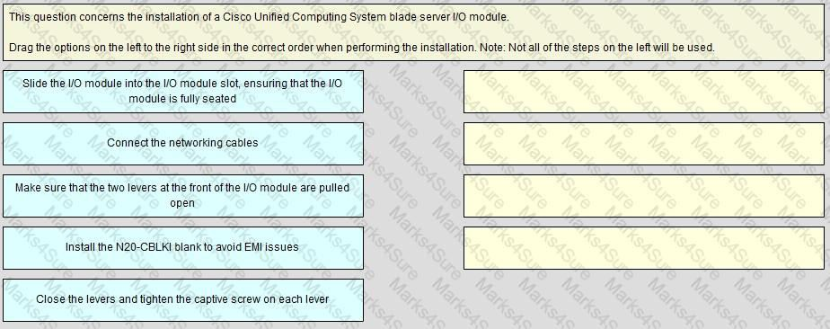

1. Organization
2. LDAP Provider Group
3. Authentication Domain

**Answer: C Explanation** Explanation Explanation/Reference:

For implementations involving multiple LDAP databases, configure an LDAP instance. Reference:

[https://www.cisco.com/c/en/us/td/docs/unified_computing/ucs/sw/sample_configurations/UCSM_1_4_LDAP_w](http://www.cisco.com/c/en/us/td/docs/unified_computing/ucs/sw/sample_configurations/UCSM_1_4_LDAP_w) [https://www.cisco.com/c/en/us/td/docs/unified_computing/ucs/ucs-manager/GUI-User-Guides/AdminManagem](http://www.cisco.com/c/en/us/td/docs/unified_computing/ucs/ucs-manager/GUI-User-Guides/AdminManagem)

Question #:85 - (Exam Topic 1)

### Answer:

Practice Test

Cisco - 300-175

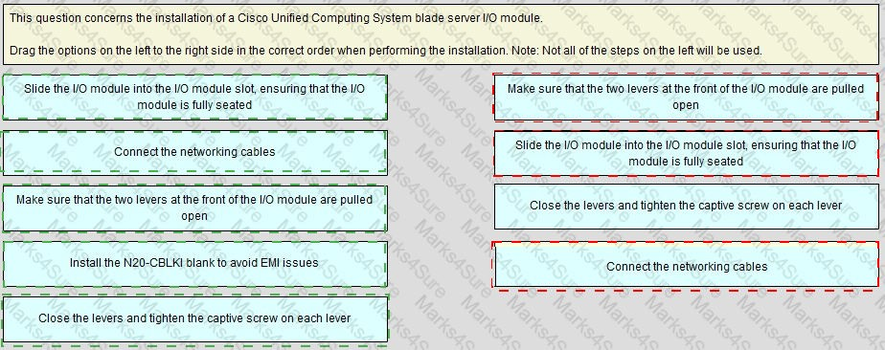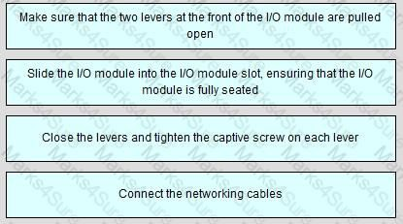

## Explanation

Question #:86 - (Exam Topic 1)

Practice Test

Cisco - 300-175

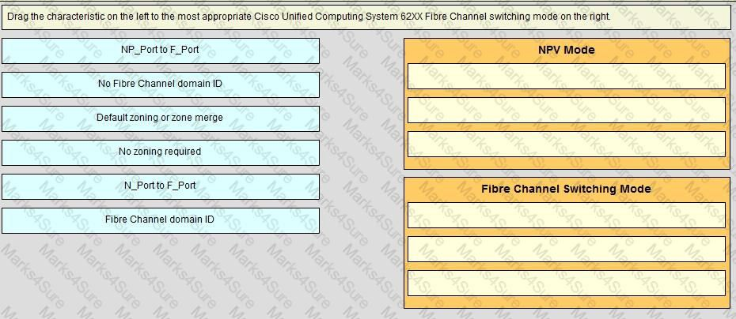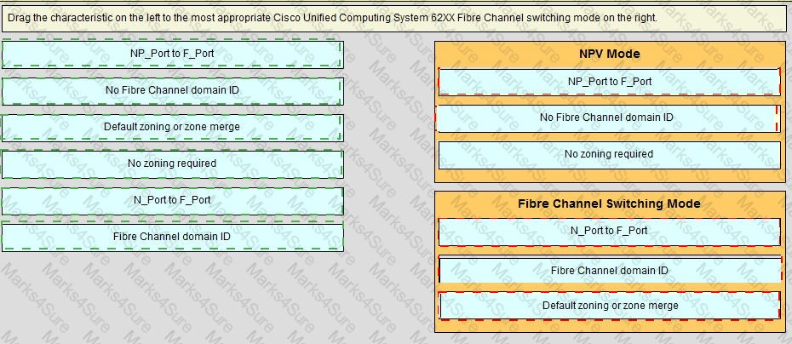

### Answer:

**Explanation**

Practice Test

Cisco - 300-175

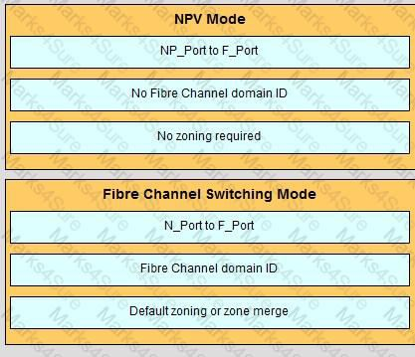

Question #:87 - (Exam Topic 1)

You must secure the default user account in a Cisco UCS domain. Which action do you take?

1. Set an account password during the initial system setup.
2. Rename the account.
3. Delete the account.
4. Set the account to lock after a specified number of failed attempts.

### Answer: A

Question #:88 - (Exam Topic 1)

Which component is unsupported by the UEFI boot device in the Cisco UCS C-series standalone?

1. PCI SSD
2. FCoE
3. FlexFlash card
4. USB

### Answer: A

Practice Test

Cisco - 300-175



Question #:89 - (Exam Topic 1)

At a customer site, a Cisco UCS cluster must be renamed due to a domain name change You need to recommend a solution to ensure that Cisco UCS Manager can be accessed over HTTPS.

Which solution accomplishes this goal?

1. The cluster must be reinstalled, in order to generate the default key ring certificate.
2. A default key ring certificate regeneration request must be issued from Cisco UCS Manager.
3. The default key ring certificate must he renewed automatically when the name changes.
4. The default key ring certificate must be regenerated manually.

**Answer: D Explanation** Explanation Explanation/Reference:

The cluster must be reinstalled, in order to generate the default key ring certificate. NOT CORRECT A default key ring certificate regeneration request must be issued from Cisco UCS Manager. NOT CORRECT (NOT AN OPTION THROUGH UCSM)

The default key ring certificate must be renewed automatically when the name changes. NOT CORRECT (NOT AUTOMATIC. MUST BE DONE THROUGH CLI)

The default key ring certificate must be regenerated manually. CORRECT [https://www.cisco.com/c/en/us/td/docs/unified_computing/ucs/sw/cli/config/guide/2-0/b_UCSM_CLI_Configur](http://www.cisco.com/c/en/us/td/docs/unified_computing/ucs/sw/cli/config/guide/2-0/b_UCSM_CLI_Configur)

The default key ring certificate must be manually regenerated if the cluster name changes or the certificate expires.

Question #:90 - (Exam Topic 1)

You have a Cisco FabricPath network. You must implement vPC+ for a downstream switch. Which three actions should you perform? (Choose three.)

1. Configure the switch ID on the peer switches.
2. Establish a peer link between the peer switches.
3. Configure the downstream switch to use PAgP on EtherChannel.

Practice Test

Cisco - 300-175



1. Connect the downstream switch to a 10-Gb port.
2. Configure the upstream switch to use PAgP on EtherChannel.
3. Configure a peer keepalive between the peer switches.

### Answer: A B C

Question #:91 - (Exam Topic 1)

Open the windows by clicking on the minimized at the bottom of the viewing area. Windows can be minimized by clicking on the [X], repositioned by dragging the title bar, and resized by using the handle at the lower right corner to customize the viewing area.

If you are required to access the devices to complete this scenario, the mouse cursor will use a hand symbol when moved over device icons. Clicking the icon will open a device terminal so you can interact with the hardware.

Open the Questions window and begin by clicking a question number. When you have completed answering all questions, click Done to continue.

Scenario

Use your UCS knowledge on Adapter errors ………………………………………configurations.

Practice Test

Cisco - 300-175

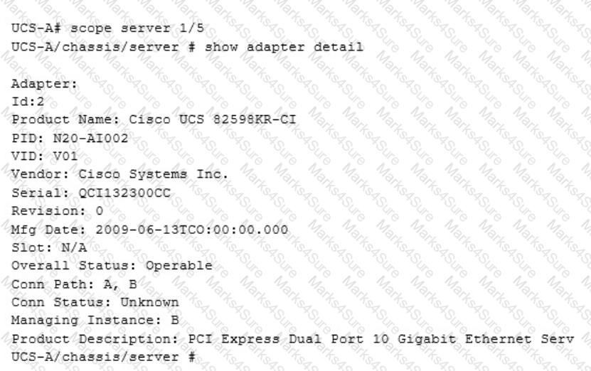

Current Adapter Connected Status is?

1. Operable
2. Down
3. Inoperable
4. Unknown

### Answer: D

Question #:92 - (Exam Topic 1)

You are configuring HTTPS access to Cisco UCS Manager. You create a key ring, you issue a certificate request for the key ring, and you create the certificate request for the key ring. You discover that you still receive untrusted connection messages when connecting to Cisco UCS Manager from a Firefox browser and a Google Chrome browser.

Practice Test

Cisco - 300-175



What should you do to resolve the issue?

1. Create a trusted point.
2. Obtain a validated certificate from Cisco.
3. Use only the Microsoft Internet Explorer browser.
4. Sign the certificate by using Cisco UCS Manager.

**Answer: A Explanation** Explanation/Reference: Reference:

[https://www.derekseaman.com/2012/04/install-trusted-ssl-certificate-in.html](http://www.derekseaman.com/2012/04/install-trusted-ssl-certificate-in.html)

Question #:93 - (Exam Topic 1)

Which two Cisco UCS firmware are contained in the Cisco UCS Infrastructure software bundle? (Choose two.)

1. Cisco I/O module firmware
2. Cisco UCS IMC
3. Cisco UCS BIOS
4. Cisco UCS fabric interconnects firmware
5. Cisco UCS adapters

**Answer: A D Explanation** Explanation Explanation/Reference: Explanation for A, D: "A" BUNDLE

Infrastructure software bundle — This bundle is also called the A bundle. It contains the firmware images that the fabric interconnects, IO Modules, and Cisco UCS Manager require to function.

Practice Test

Cisco - 300-175



"B" BUNDLE

* 1. eries server software bundle — Also called the B bundle, this bundle contains the firmware images that the B-Series blade servers require to function, such as adapter, BIOS, CIMC, and board controller firmware.

Release Bundle Contents for Cisco UCS Manager, Release 3.1 provides details about the contents of the BSeries server software bundle.

Reference:

[https://www.cisco.com/c/en/us/td/docs/unified_computing/ucs/ucs-manager/GUI-User-Guides/FirmwareMgmt/3](http://www.cisco.com/c/en/us/td/docs/unified_computing/ucs/ucs-manager/GUI-User-Guides/FirmwareMgmt/3) b_UCSM_GUI_Firmware_Management_Guide_3_1_chapter_01.html

Question #:94 - (Exam Topic 1)

Which two statements are true concerning the role-based access control specifics of a Cisco Unified Computing System? (Choose two.)

* + 1. By default, user accounts expire after 90 days; a warning message will he generated 10 days prior to expiration.
    2. A locally authenticated user account is any user account that is authenticated through LDAP, RADIUS. or TACACS+.
    3. A user that is assigned one or more roles will be allowed the privileges that are consistent across all of the assigned roles.
    4. All roles include read access to all configuration settings in the Cisco Unfiled Computing System domain.
    5. If a user maintains a local user account and a remote user account simultaneously, the roles that are defined in the local user account override those that are maintained in the remote user account.

**Answer: D E Explanation** Explanation Explanation/Reference: Reference:

[https://www.cisco.com/c/en/us/td/docs/unified_computing/ucs/ucs-manager/GUI-User-Guides/AdminManagem](http://www.cisco.com/c/en/us/td/docs/unified_computing/ucs/ucs-manager/GUI-User-Guides/AdminManagem)

Question #:95 - (Exam Topic 1)

Refer to the exhibit.

Practice Test

Cisco - 300-175

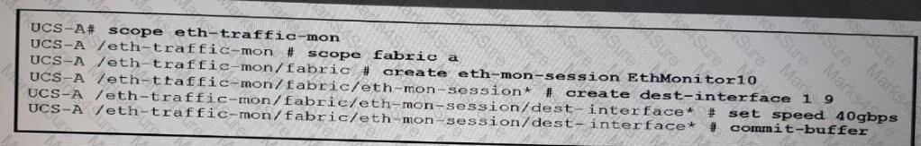

Which description of the result is true?

1. An Ethernet monitoring session was created where traffic may be copied and forwarded to slot 1 port 9 for analysis.
2. An Ethernet monitoring session was created, activated and committed.
3. Ethernet traffic from slot 9 port 1 will be copied and forwarded to the destination SPAN port for analysis.
4. Ethernet traffic from slot 1 port 9 will be copied and forwarded to the destination SPAN port for analysis.

### Answer: A

Question #:96 - (Exam Topic 1)

To provide stronger authentication for Cisco UCS manager, You are installing a third-party certificate from a trusted point. Which format must the certificate be in?

1. DER
2. PEM
3. CRT
4. CER (x.509)

**Answer: D Explanation Trusted Points**

To provide stronger authentication for Cisco UCS Manager, you can obtain and install a third-party certificate from a trusted source, or trusted point, that affirms the identity of your device. The third-party certificate is signed by the issuing trusted point, which can be a root certificate authority (CA) or an intermediate CA or trust anchor that is part of a trust chain that leads to a root CA. To obtain a new certificate, you must generate a certificate request through Cisco UCS Manager and submit the request to a trusted point.

Practice Test

Cisco - 300-175



Important:

The certificate must be in Base64 encoded X.509 (CER) format.

Question #:97 - (Exam Topic 1)

You need to upgrade the firmware on 15 Cisco UCS C-Series Rack Servers. Ten of the servers are integrated in a Cisco UCS cluster, and the other five servers are used in standalone mode. The Cisco UCS C-Series Rack-Mount Server Software Bundle is available.

Which set of statements about the upgrade process is true?

1. You cannot upgrade the firmware on the servers in standalone mode. You must cluster the servers first over LAN or via cluster interfaces. After the firmware upgrade, you can revert the five servers to standalone mode.
2. You cannot use the Cisco UCS C-Series Rack-Mount Server Software Bundle with Cisco UCS C-Series Servers in standalone mode. You must download and use the Cisco UCS C-Series Rack-Mount Standalone Server Software package.
3. First, you must integrate the standalone servers into the Cisco UCS system. Then, you can upgrade the firmware on all 15 servers from Cisco UCS Manager. Finally, you can revert the five servers to standalone mode.
4. You can upgrade the firmware on all of the Cisco UCS C-Series Rack Servers by using the Cisco UCS C-Series Rack-Mount Standalone Server Software. You can upgrade the 10 servers that are integrated in a Cisco UCS cluster in Cisco UCS Manager, and you can upgrade the five standalone servers one by one.

**Answer: C Explanation** Explanation/Reference: Reference:

[https://www.cisco.com/c/en/us/td/docs/unified_computing/ucs/c-series_integration/ucsm3-1/b_C-SeriesIntegrati](http://www.cisco.com/c/en/us/td/docs/unified_computing/ucs/c-series_integration/ucsm3-1/b_C-SeriesIntegrati)

Question #:98 - (Exam Topic 1)

Which two features in Cisco UCS Manager can be configured from LAN Uplinks Manager? (Choose two.)

1. vNIC templates
2. LAN Pin Groups
3. VLAN groups

Practice Test

Cisco - 300-175

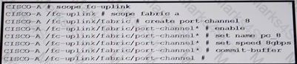

1. adapter policies
2. link profiles

### Answer: B C

Question #:99 - (Exam Topic 1)

Refer to the exhibit.

Which two action do you perform on the remote switch before you run the commands? 9Choose two)

1. Configure a minimum of eight links in the port channel.
2. Configure the remote switch to use NPIV mode.
3. Set port channel mode to on.
4. Configure the remote switch for NPV.
5. Enable the port-channel-trunk feature.

### Answer: B E

Question #:100 - (Exam Topic 1)

Which two items represent the features of Call Home on the Cisco Unified Computing System? (Choose two.)

1. send fault details to Cisco TAC
2. SNMP trap receiver
3. syslog
4. central repository of normalized fault data
5. send email alerts to administrators

### Answer: A E

Practice Test

Cisco - 300-175



Question #:101 - (Exam Topic 1)

Which two Cisco UCS components require drivers? (Choose two.)

1. FNIC
2. BIOS
3. CIMC
4. board controller
5. ENIC

### Answer: A E

Question #:102 - (Exam Topic 1)

An engineer is performing firmware upgrades through Cisco USC Manager.

Which firmware upgrade causes the server to be powered off during the upgrade and powered on after the upgrade is complete?

1. adapter
2. board controller
3. BIOS
4. storage controller

### Answer: C

Question #:103 - (Exam Topic 1)

A Cisco UCS administrator configuring QoS. Which two options are valid QoS system classes in a Cisco UCS blade system? (Choose two.)

1. Drop eligible
2. Transactaional data
3. Best effort
4. Scavenger

Practice Test

Cisco - 300-175

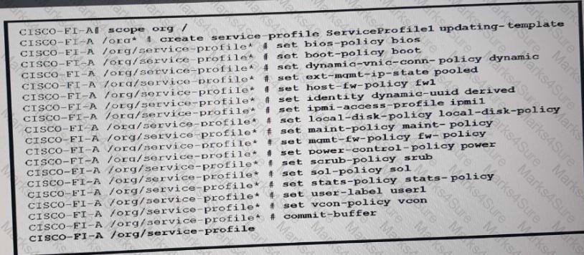

1. Fibre Channel

### Answer: C E

Question #:104 - (Exam Topic 1)

Refer to the exhibit.

Which result of configuring ServiceProfile 1 is true?

1. It upgrades the firmware immediately.
2. It restricts editing of ServiceProfile 1 to the members of the user 1 group.
3. It associates the fw 1 firmware policy to ServiceProfile 1.
4. It sets the firewall policy on the host to fw 1.

### Answer: C

Question #:105 - (Exam Topic 1)

Open the windows by clicking on the minimized at the bottom of the viewing area. Windows can be minimized by clicking on the [X], repositioned by dragging the title bar, and resized by using the handle at the lower right corner to customize the viewing area.

Practice Test

Cisco - 300-175

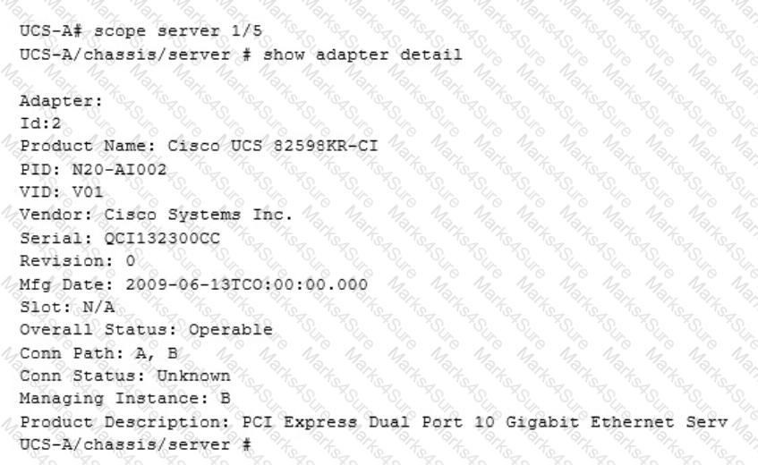

If you are required to access the devices to complete this scenario, the mouse cursor will use a hand symbol when moved over device icons. Clicking the icon will open a device terminal so you can interact with the hardware.

Open the Questions window and begin by clicking a question number. When you have completed answering all questions, click Done to continue.

Scenario

Use your UCS knowledge on Adapter errors ………………………………………configurations.

We are working on which server?

1. 1
2. 2
3. 3
4. 4

Practice Test

Cisco - 300-175



1. 5

### Answer: E

Question #:106 - (Exam Topic 1)

Before upgrading a Cisco UCS cluster.you need to verify the high-availability statue and roles of the cluster. In which scenario can you successfully perform the upgrade'?

1. When you check the Cisco UCS Manager GUI, the Ready field value is Ready and the State field value is On. When you check the Cisco UCS Manager CLI, the Primary and Secondary interconnect state are both ON and the cluster state is HA WAITING.
2. When you check the Cisco UCS Manager GUI, the Ready field value is Yes and the State field value is Up. When you check the Cisco UCS Manager CLI, the Primary and Secondary interconnect state are both UP and the cluster state is HA READY.
3. When you check the Cisco UCS Manager GUI, the Ready field value is Ready and the State field value is Active. When you check the Cisco UCS Manager CLI, the Primary and Secondary interconnect state are both READY and the cluster state is HA WAITING.
4. When you check the Cisco UCS Manager GUI, the Ready field value is Ready and the State field value is Up. When you check the Cisco UCS Manager CLI, the Primary and Secondary interconnect state are both UP and the cluster state is HA UP.

**Answer: B Explanation** Explanation Explanation/Reference:

When you check the Cisco UCS Manager GUI, the Ready field value is Yes and the State field value is Up.

When you check the Cisco UCS Manager CLI, the Primary and Secondary interconnect state are both UP and the cluster state is HA READY.

Reference:

[https://www.cisco.com/c/en/us/td/docs/unified_computing/ucs/sw/firmware-mgmt/gui/2-2/](http://www.cisco.com/c/en/us/td/docs/unified_computing/ucs/sw/firmware-mgmt/gui/2-2/) b_GUI_Firmware_Management_22/b_GUI_Firmware_Management_22_chapter_011.pdf

[https://www.cisco.com/c/en/us/td/docs/unified_computing/ucs/ucs-manager/CLI-User-Guides/FirmwareMgmt/3](http://www.cisco.com/c/en/us/td/docs/unified_computing/ucs/ucs-manager/CLI-User-Guides/FirmwareMgmt/3)

Question #:107 - (Exam Topic 1)

Practice Test

Cisco - 300-175



Which item describes the failure scenario called a "split-brain" in the Cisco Unified Computing System?

1. Failure of the Cisco Unified Computing System L1-L2 network
2. Failure of a Cisco Unified Computing System Chassis Management Controller
3. Failure of a Cisco Unified Computing System I/O module
4. Failure of a Cisco Unified Computing System Fabric Interconnect
5. Failure of a Cisco Unified Computing System Chassis Management Switch

### Answer: A

Question #:108 - (Exam Topic 1)

Which two statements describe the Cisco UCS Manager full state type of backup? (Choose two.)

1. The file created can be used for an import.
2. The file created cannot be used to restore the system during disaster recovery.
3. The file created can only be used to restore a system that is running the same version as the system from which the backup file was exported.
4. It creates an XML file.
5. It creates binary file.

### Answer: D E

Question #:109 - (Exam Topic 1)

Which ports can access the Cisco IMC if you select Shared LOM NIC mode in the Cisco IMC Configuration Utility for a Cisco UCS C-Series server?

1. The ports on an installed Cisco network adapter card
2. The two 1-Gb Ethernet ports
3. The two 10/100 management ports
4. The two 10/100 management ports, but each port has a default setting

### Answer: B

Practice Test

Cisco - 300-175

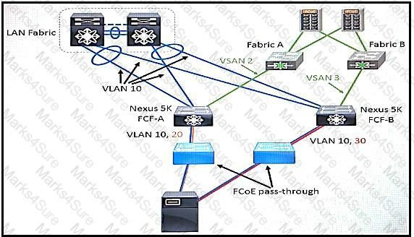

Question #:110 - (Exam Topic 1)

You are configuring RBAC on a Cisco UCS system. What happens when you assign multiple locales to user?

1. Access to denied to all organizations.
2. Access is granted to only the first organization that is specific in the locales.
3. access is granted to only the first organization that is specified in the locales.
4. Access is granted to all organizations that are specifications in the locales.

### Answer: D

Question #:111 - (Exam Topic 1)

View the Exhibit.

Refer to the exhibit. Which type of FCoE topology is displayed?

1. direct-attach
2. remote-attach
3. vPC
4. FCoE with Cisco 2232 Fabric Extenders

### Answer: B

Practice Test

Cisco - 300-175



**Explanation** Explanation Explanation/Reference: Reference:

[https://www.cisco.com/c/en/us/products/collateral/switches/nexus-7000-series-switches/white_paper_c11-56040](http://www.cisco.com/c/en/us/products/collateral/switches/nexus-7000-series-switches/white_paper_c11-56040)

Question #:112 - (Exam Topic 1)

You have a Cisco Nexus switch in NPV mode. Which technology do you use to enhance load balancing, capacity, and resiliency for the devices FLOGI'd into this switch?

1. FabricPath
2. F-port-channel-trunk
3. Overlay vNIC
4. FCoE

### Answer: B

Question #:113 - (Exam Topic 1)

Which description of an import operation in Cisco UCS Manager is true?

1. You can choose to merge or replace the existing UCS configuration during an import.
2. You can import only a configuration file that was exported from the same Cisco UCS Manager.
3. You can import a configuration from a higher release to a lower release.
4. You can schedule an import operation.

### Answer: A

Question #:114 - (Exam Topic 1)

Refer to the exhibit.

Practice Test

Cisco - 300-175

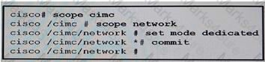

Which port is used for communication between the server and the Cisco Integrated management Controller?

1. port on the adapter card
2. management Ethernet port
3. LAN on the motherboard port
4. fabric uplink port

### Answer: B

Question #:115 - (Exam Topic 1)

Which two statements about service profile configuration option in the Cisco UCS Manager GUI are true? (Choose two.)

1. It can be configured by using the chassis connectivity plicy.
2. it can be derived from the chassis discovery policy.
3. it can be generated automatically from the service profile template.
4. it can be configured by cloning a virtual machine profile
5. it can be derived from the initial template or the updating template.

### Answer: D E

Question #:116 - (Exam Topic 1)

You need to upgrade the firmware on a Cisco UCS B-Series Blade Server system. Drag and drop the firmware packages on the left to the appropriate software bundle types on the right.

Practice Test

Cisco - 300-175

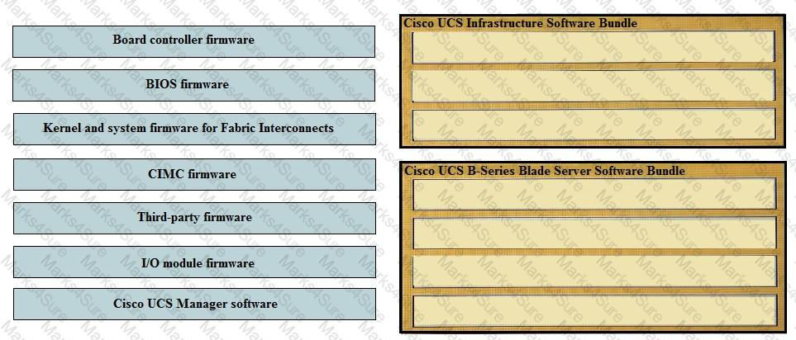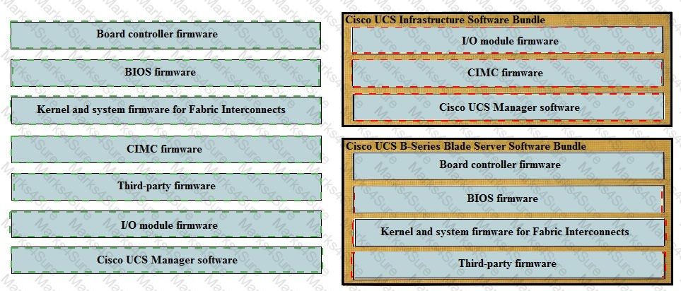

### Answer:

**Explanation**

Practice Test

Cisco - 300-175



Cisco UCS Infrastructure Software Bundle I/O module firmware

CIMC firmware

Cisco UCS Manager firmware

Cisco UCS B-series Blade Server Software Bundle Board controller firmware

BIOS firmware

Kernel and system firmware for Fabric Interconnects Third-party firmware

Question #:117 - (Exam Topic 1)

Which solution enables Cisco devices to be monitored with automated support capabilities?

1. Cisco Intelligent Monitoring Agent
2. Cisco Intersight
3. connected Service Assurance
4. Two-Tier Smarrt Agent

### Answer: B

Question #:118 - (Exam Topic 1)

Which option does UEFI secure boot provide?

1. checksum verification of the OS
2. certificate verification of the EFI shell
3. checksum verification of the EFI shell
4. certificate verification of the OS

### Answer: D

Practice Test

Cisco - 300-175



Question #:119 - (Exam Topic 1)

You need to configure storage switch-based Fibre Channel zoning in a Cisco UCS system. The zoning must be configured in VSAN 100.

What should you do?

1. Disable zoning on VSAN 100 in Cisco UCS Manager. Configure zoning on the upstream SAN switch on VSAN 100.
2. Disable zoning on VSAN 100 in Cisco UCS Manager. Set Cisco UCS Manager to interoperability mode. Create VSAN 100 in Cisco UCS Manager. Configure zoning on the upstream third-party SAN switch.
3. Register the SAN switch manually in Cisco UCS Manager. Enable switch-based zoning on VSAN 100 in Cisco UCS Manager.
4. Discover the SAN switch in Cisco UCS Manager. Enable inherited zoning on VSAN 100 in Cisco UCS Manager.

### Answer: C

Question #:120 - (Exam Topic 1)

Which set of statements about the deployment options for Cisco UCS Central Software is true?

1. Cisco UCS Central Software can be installed in a physical or a hypervisor environment. Only VMware and KVM hypervisor environments are supported.
2. Cisco UCS Central Software can he installed in a physical or a hypervisor environment. VMware, Microsoft Hyper-V, and KVM hypervisor environments are supported.
3. Cisco UCS Central Software can be installed only in a physical environment, due to extreme I/O and networking needs.
4. Cisco UCS Central Software can be installed only in a VMware and Microsoft Hyper-V virtual environment.

**Answer: A Explanation** Explanation Explanation/Reference:

UCS Central can only be installed in a hypervisor, but may be installed in VMW are ESXi, Hyper-V, and KVM.

Practice Test

Cisco - 300-175



This isn't an option Reference:

[https://www.cisco.com/c/en/us/td/docs/unified_computing/ucs/ucs-central/install-upgrade/1-3/b_Cisco_UCSC_I](http://www.cisco.com/c/en/us/td/docs/unified_computing/ucs/ucs-central/install-upgrade/1-3/b_Cisco_UCSC_I)

Question #:121 - (Exam Topic 1)

Open the windows by clicking on the minimized title at the bottom of the viewing area. Windows can be minimized by clicking on the [-], repositioned by dragging the title bar, and resized by using the handle at the lower right corner to customize the viewing area.

If you are required to access the devices to complete this scenario, the mouse cursor will use a hand symbol when moved over device icons. Click the icon to open a device terminal to interact with the hardware.

Open the Questions window and begin with clicking a question number. When you have completed answering all questions, click Done to continue.

Scenario

Use your UCS knowledge on Fabric Interconnect Failover to answer the questions associated with the UCS cluster.

Exhibit.

Practice Test

Cisco - 300-175

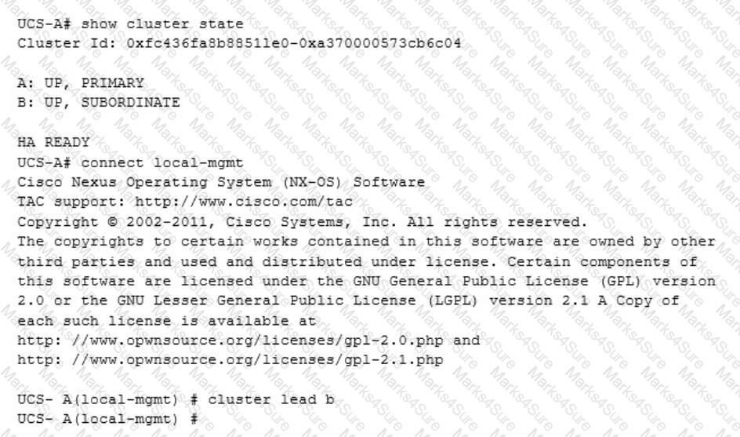

Which statements is true regarding the Fabric Interconnect Failover configuration changes?

1. High availability is being setup so that cluster a and b can both be subordinate or primary.
2. The fabric interconnect b changes from subordinate to primary.
3. High availability is setup so that fabric interconnect will keep a to be primary and b will be lead.
4. The Fabric interconnect can have lead states, so that b will switch to primary and a will stay primary.

### Answer: B

Question #:122 - (Exam Topic 1)

You want to modify a service profile that is bound to an updating template. Which description of the relationship between the service profile and the updating template is true?

Practice Test

Cisco - 300-175



1. The service profile is updated after the server reboots.
2. The service profile is updated automatically when the updating template changes.
3. Change to the updating template apply only to service profile created after template after the template is updated.
4. The updating template can be changed only before the service profile is implemented

### Answer: D

Question #:123 - (Exam Topic 1)

Which two tasks can you perform from Cisco UCS Manager? (Choose two.)

1. Configure SAN PIN groups.
2. Restart an Oracle database.
3. Configure or manage external storage on the SAN.
4. Configure QoS classes and definitions.
5. Deploy an operating system.

**Answer: A D Explanation** Explanation/Reference:

Restart an Oracle database. NOT CORRECT Deploy an operating system. NOT CORRECT

Configure or manage external storage on the SAN. NOT CORRECT [https://www.cisco.com/c/en/us/td/docs/unified_computing/ucs/sw/gui/config/guide/2-2/b_UCSM_GUI_Configu](http://www.cisco.com/c/en/us/td/docs/unified_computing/ucs/sw/gui/config/guide/2-2/b_UCSM_GUI_Configu) [https://www.cisco.com/c/en/us/support/docs/servers-unified-computing/ucs-2104xp-fabric-extender/110509-ucs](http://www.cisco.com/c/en/us/support/docs/servers-unified-computing/ucs-2104xp-fabric-extender/110509-ucs) [https://www.cisco.com/c/en/us/td/docs/unified_computing/ucs/sw/gui/config/guide/1-0-2/b_GUI_Config_Guide](http://www.cisco.com/c/en/us/td/docs/unified_computing/ucs/sw/gui/config/guide/1-0-2/b_GUI_Config_Guide)

Question #:124 - (Exam Topic 1)

Which description of an import operation in Cisco UCS Manager is true?

1. You can perform an import while the system is up and running.

Practice Test

Cisco - 300-175

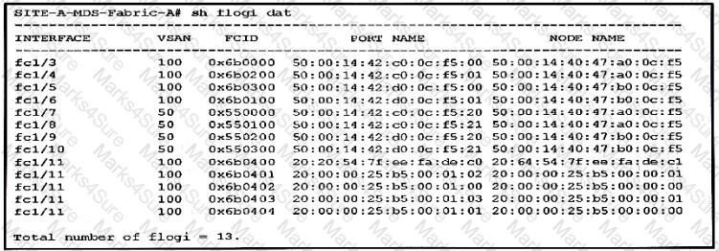

1. You can import only a configuration file that was exported from the same Cisco UCS Manager.
2. You can import a configuration from a higher release to a lower release.
3. You can schedule an import operation.

**Answer: A Explanation** Explanation Explanation/Reference:

You can perform an import while the system is up and running.

You can import any configuration file that was exported from Cisco UCS Manager. The file does not need to have been exported from the same Cisco UCS Manager. You cannot schedule an import operation.

Reference: [https://www.cisco.com/en/US/docs/unified_computing/ucs/sw/gui/config/guide/141/](http://www.cisco.com/en/US/docs/unified_computing/ucs/sw/gui/config/guide/141/)

UCSM_GUI_Configuration_Guide_141_chapter43.html#task_B89DEDCFCDE54E9C81E67C53FAC4DEC6 [https://www.cisco.com/c/en/us/td/docs/unified_computing/ucs/ucs-manager/GUI-User-Guides/AdminManagem](http://www.cisco.com/c/en/us/td/docs/unified_computing/ucs/ucs-manager/GUI-User-Guides/AdminManagem) b_Cisco_UCS_Admin_Mgmt_Guide_3_1_chapter_01001.pdf

You cannot import configuration from a higher release to a lower release.

Question #:125 - (Exam Topic 1)

View the Exhibit.

Practice Test

Cisco - 300-175



Refer to the exhibit. You need to configure a Fibre Channel device alias named TEST for a device that is attached to port fc 1/9 of a Cisco Nexus Series switch in a Cisco UCS system.

Which command set should you use?

1. SITE-A-MDS-Fabric-A# configure terminalSITE-A-MDS-Fabric-A (config)# device-alias databaseSITE-A-MDS-Fabric-A (config-device-alias-db)# device-alias name TEST pwwn 50:00:14:42:d0:0c:f5:20SITE-A-MDS-Fabric-A (config-device-alias-db)# exit
2. SITE-A-MDS-Fabric-A# configure terminalSITE-A-MDS-Fabric-A (config)# device-alias databaseSITE-A-MDS-Fabric-A(config-device-alias-db)# device-alias name TEST pwwn 50:00:14:40:47:b0:0c:f5SITE-A-MDS-Fabric-A (config-device-alias-db)# device-alias commit
3. SITE-A-MDS-Fabric-A# configure terminalSITE-A-MDS-Fabric-A (config)# device-alias databaseSITE-A-MDS-Fabric-A (config-device-alias-db)# device-alias name TEST pwwn 50:00:14:42:d0:0c:f5:20SITE-A-MDS-Fabric-A (config-device-alias-db)# device-alias commit
4. SITE-A-MDS-Fabric-A# device-alias databaseSITE-A-MDS-Fabric-A (device-alias-db)# device-alias name TEST pwwn 50:00:14:40:47:b0:0c:f5SITE-A-MDS-Fabric-A (config-device-alias-db)#

device-alias commit

**Answer: B Explanation** Explanation/Reference: Reference:

[https://www.cisco.com/c/en/us/td/docs/switches/datacenter/mds9000/sw/4_1/configuration/guides/cli_4_1/clibo](http://www.cisco.com/c/en/us/td/docs/switches/datacenter/mds9000/sw/4_1/configuration/guides/cli_4_1/clibo) https://community.emc.com/thread/170991?start=0&tstart=0

We need to zone the PWWN (port WWN) of fc1/9, not the NWWN (node WWN) of fc1/9

Question #:126 - (Exam Topic 1)

Which two features in Cisco UCS Manager are required to configure Uplink Ethernet ports? (Choose two.)

1. vNIC templates
2. LAN Pin Groups
3. VLAN groups
4. adapter policies
5. link profiles

Practice Test

Cisco - 300-175



**Answer: A B Explanation** Explanation Explanation/Reference: Reference:

[https://www.cisco.com/c/en/us/support/docs/servers-unified-computing/ucs-6120xp-20-port-fabricinterconnect/1](http://www.cisco.com/c/en/us/support/docs/servers-unified-computing/ucs-6120xp-20-port-fabricinterconnect/1)

[https://www.cisco.com/c/en/us/td/docs/unified_computing/ucs/sw/gui/config/guide/2-2/](http://www.cisco.com/c/en/us/td/docs/unified_computing/ucs/sw/gui/config/guide/2-2/) b_UCSM_GUI_Configuration_Guide_2_2/using_the_lan_uplinks_manager.html

Question #:127 - (Exam Topic 1)

Which option describes the Network Security feature of Cisco intergrated Management Controller?

1. User-configured ACLs that deny devices access to the Cisco IMC.
2. 802.1x support which permits the Cisco IMC access to the port security network.
3. A feature that locks users out of the Cisco IMC after a specified number of unsuccessful log in attempts.
4. A list that specifies the devices allowed to access the Cisco IMC.

### Answer: C

Question #:128 - (Exam Topic 1)

When performing a backup through Cisco UCS Manager, which backup type must you to backup locally authenticated users?

1. System configuration
2. All configuration
3. Full State
4. Logical Configuration

**Answer: A Explanation** Explanation/Reference:

Practice Test

Cisco - 300-175



System configuration - An XML file that includes all system configuration settings such as usernames, roles, and locales. You can use the file generated from this backup to import these configuration settings to the original fabric interconnect or to a different fabric interconnect. You cannot use this file for a system restore.

Reference:

[https://www.cisco.com/c/en/us/td/docs/unified_computing/ucs/sw/gui/config/guide/2-0/b_UCSM_GUI_Configu](http://www.cisco.com/c/en/us/td/docs/unified_computing/ucs/sw/gui/config/guide/2-0/b_UCSM_GUI_Configu)

Question #:129 - (Exam Topic 1)

You need to design and implement a Cisco UCS 5108 Blade Server Chassis system for a customer. Which statement about how half-width blades and full-width blades can be used is true?

1. Only two full-width blades can be installed in the top two slots, and four half-width blades can be installed in the bottom two slots.
2. Only one full-width blade can be installed in the top slot, and six half-width blades can be installed in the bottom slots.
3. Half-width blades and full-width blades can be combined in any order.
4. Half-width blade types and full-width blade types cannot be combined.

**Answer: C Explanation** Explanation Explanation/Reference:

Mixed blade configurations Allows up to 8 half-width or 4 full-width blade servers, or any combination thereof, for outstanding flexibility.

When configured with the 6324 Fabric Interconnect, only 8 half-width B200 M3 blades are supported.

[https://www.cisco.com/c/en/us/td/docs/unified_computing/ucs/hw/chassis-install-guide/ucs5108_install/](http://www.cisco.com/c/en/us/td/docs/unified_computing/ucs/hw/chassis-install-guide/ucs5108_install/) ucs5108_install_chapter_01.htm

Question #:130 - (Exam Topic 1)

You have a Cisco UCS system. You need to create VSAN 100 on 2 Cisco Nexus Series switch and to enable switch port fc1/10 as a member for the VLAN.

Which command set should you use?

1. SITE-A-MDS-Fabric-A# vsandatabaseSITE-A-MDS-Fabric-A (vsan-db)#vsan 100 interface fc1/10SITE-A-MDS-Fabric-A (vsan-db)# vsan database commitSITE-A-MDS-Fabric-A (vsan-db)# exit

Practice Test

Cisco - 300-175



1. SITE-A-MDS-Fabric-A# configure terminalSITE-A-MDS-Fabric-A (config)#vsandatabaseSITE-A-MDS-Fabric-A (config-vsan-db)# vsan 100 interface fc1/10SITE-A-MDS-Fabric-A (config-vsan-db)# exit
2. SITE-A-MDS-Fabric-A# configure terminal SITE-A-MDS-Fabric-A (config)# vsandatabaseSITE-A-MDS-Fabric-A (config-vsan-db)# vsan 100 interface fc1/10SITE-A-MDS-Fabric-A (config-vsan-db)# vsan database commit
3. SITE-A-MDS-Fabric-A# configure terminalSITE-A-MDS-Fabric-A (config)# vsandatabaseSITE-A-MDS-Fabric-A(config-vsan-db)# vsan 100 interface

fc1/10SITE-A-MDS-Fabric-A (config-vsan-db)# vsan database commitSITE-A-MDS-Fabric-A (config-vsan-db)# exit

**Answer: D Explanation** Explanation Explanation/Reference: Reference:

[https://www.cisco.com/en/US/docs/storage/san_switches/mds9000/sw/san-os/quick/guide/qcg_vin.html](http://www.cisco.com/en/US/docs/storage/san_switches/mds9000/sw/san-os/quick/guide/qcg_vin.html)

Question #:131 - (Exam Topic 1)

You are using UCS version 2.4 or later and need to advertise the identity of a server by using LLDP instead of CDP. Which policy in the vNIC template accomplishes this goal?

1. Ethernet adapter
2. network control
3. QoS
4. LAN connectivity

### Answer: D

Practice Test

Cisco - 300-175



# Topic 2, Exam Set 1

Question #:132 - (Exam Topic 2)

Which option describes the possible result of a customer configuring a server pool that contains Cisco UCS B200 M2 and B250 M2 blades?

1. A service profile cannot migrate automatically from one blade to another blade within the server pool due to hardware failure.
2. You must decommission a blade server for the associated service profile to migrate to another blade in the server pool successfully.
3. You must uncheck the Restrict Migration box in the service profile to allow service profile migration between blades in the server pool.
4. After service profile migration, the server fails in boot from SAN due to differences in PCI device IDs.

### Answer: D

Question #:133 - (Exam Topic 2)

If a customer wants to maximize the capability of server mobility with the Cisco UCS deployment, what two options are Cisco recommended? (Choose two.)

1. Configure a server inheritance policy.
2. Configure a Virtual Media boot.
3. Configure a hardware-based service profile with burned-in addresses and identities.
4. Configure boot from SAN.
5. Configure service profiles with resource pools.

### Answer: D E

Question #:134 - (Exam Topic 2)

Which options are valid port types when configuring fixed 10-Gb LAN interfaces on the Cisco UCS 6200 Series Fabric Interconnects? (Choose three.)

1. monitoring port
2. server port

Practice Test

Cisco - 300-175



1. uplink Ethernet port
2. FEX port
3. Fibre Channel storage port

### Answer: A B C

Question #:135 - (Exam Topic 2)

Which policy would you change to form a port channel between a Cisco UCS 6248 and a Cisco UCS 2208?

1. link aggregation policy
2. chassis discovery policy
3. IOM connection policy
4. link discovery policy

### Answer: B

Question #:136 - (Exam Topic 2)

In a standalone Cisco UCS C-Series server, which recommendations can be used to upgrade the BIOS?

1. Cisco IMC
2. Cisco UCS Manager
3. iFlash32 Utility
4. Flash ROM Utility
5. EFI Interface
6. Cisco Host Upgrade Utility
7. USB Flash Utility

### Answer: F

Question #:137 - (Exam Topic 2)

Practice Test

Cisco - 300-175



### Answer:

Practice Test

Cisco - 300-175



**Explanation**

Practice Test

Cisco - 300-175



Question #:138 - (Exam Topic 2)

### Answer:

Practice Test

Cisco - 300-175



## Explanation

Question #:139 - (Exam Topic 2)

Which two options occur when a server discovery policy is invoked? (Choose two.)

1. executes the qualification in the server discovery policy against the server
2. applies the scrub policy to the server
3. analyzes the inventory of the server
4. assigns the server to the selected organization, if configured
5. creates a service profile for the server with the identity burned into the server at time of manufacture

### Answer: A B

Practice Test

Cisco - 300-175



## Explanation

Explanation/Reference:

Configuring Server Discovery Policies Server Discovery Policy

This discovery policy determines how the system reacts when you add a new server. If you create a server discovery policy, you can control whether the system conducts a deep discovery when a server is added to a chassis, or whether a user must first acknowledge the new server. By default, the system conducts a full discovery.

If you create a server discovery policy, the following occurs when a new server starts: The qualification in the server discovery policy is executed against the server.

If the server meets the required qualifications, Cisco UCS Manager applies the following to the server:

Depending upon the option selected for the action, either discovers the new server immediately or waits for a user to acknowledge the new server

Applies the scrub policy to the server Reference:

[http://www.cisco.com/c/en/us/td/docs/unified_computing/ucs/sw/gui/config/guide/2-1/b_UCSM_GUI_Configur](http://www.cisco.com/c/en/us/td/docs/unified_computing/ucs/sw/gui/config/guide/2-1/b_UCSM_GUI_Configuration_Guide_2_1/b_UCSM_GUI_Configuration_Guide_2_1_chapter_011110.html#d184122e6834a1635)

Question #:140 - (Exam Topic 2)

Which NIC redundancy modes allow the LOMs to be discovered by the operating system or hypervisor?

1. Dedicated mode
2. Active/Active
3. Active/Standby
4. Cisco Card Mode

### Answer: A

Question #:141 - (Exam Topic 2)

Which two elements are defined in a dynamic vNIC connection policy? (Choose two.)

1. adapter policy

Practice Test

Cisco - 300-175



1. QoS policy
2. network control policy
3. number of dynamic vNICs
4. jumbo frame size

### Answer: A D

Question #:142 - (Exam Topic 2)

When implementing a Cisco UCS C-series standalone server, which of the following Cisco Integrated Management Controller NIC modes allow use of the least number of physical ports while providing maximum levels of redundancy?

1. dedicated
2. shared LOM
3. shared LOM 10G
4. Cisco VIC

### Answer: D

Question #:143 - (Exam Topic 2)

What is the maximum number of ports on a VMware vCenter Distributed Virtual Switch?

A. 64 B. 128 C. 1024 D. 4096 E. 8192

### Answer: D

Question #:144 - (Exam Topic 2)

Which of the following is not a feature of the Cisco Unified Computing System VIC-1280 adaptor?

Practice Test

Cisco - 300-175



1. capable of up to 256 virtual interfaces
2. supports FCoE
3. supports Cisco VM-FEX
4. compatible with the C- or B-Series Cisco Unified Computing System servers

### Answer: D

Question #:145 - (Exam Topic 2)

Which three items represent some of the features that can be defined in a Cisco Unified Computing System Manager port profile? (Choose three.)

1. QoS policy
2. ACL
3. NetFlow
4. port security
5. network control policy
6. VLAN or VLANs

### Answer: A E F

Question #:146 - (Exam Topic 2)

Which two items can you provision in a vHBA Template? (Choose two.)

1. Max Data Field Size
2. SCSI I/O Queues
3. FCoE VLAN
4. vHBA Interrupt Mode
5. Stats Threshold Policy
6. FLOGI Timeout

### Answer: A E

Practice Test

Cisco - 300-175



Question #:147 - (Exam Topic 2)

Which BIOS setting is required for a VMware ESXi 5.0 host to support Cisco VM-FEX universal pasthrough mode?

1. VT for Directed IO
2. ACPI 10 Support
3. VEMDPA Agent
4. Execute Disabled Bit
5. Processor C State

### Answer: A

Question #:148 - (Exam Topic 2)

Which backup option must be used for a system restore?

1. full state
2. all configuration
3. system configuration
4. logical configuration
5. incremental

### Answer: A

Question #:149 - (Exam Topic 2)

Practice Test

Cisco - 300-175

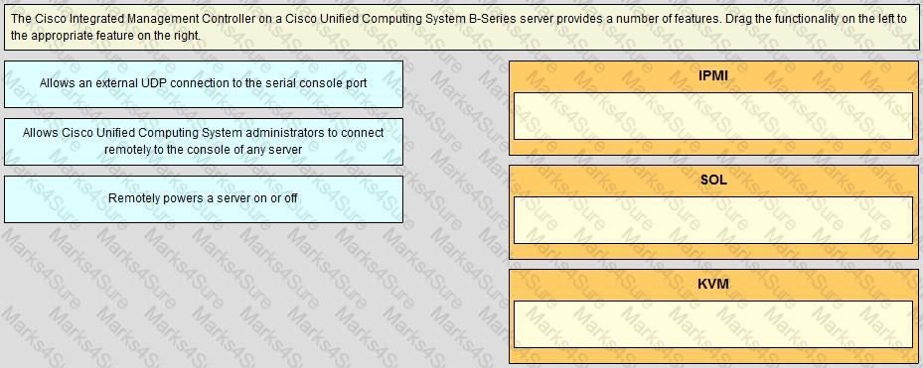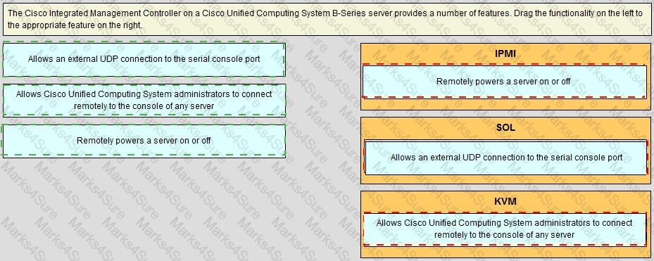

### Answer:

**Explanation**

Practice Test

Cisco - 300-175

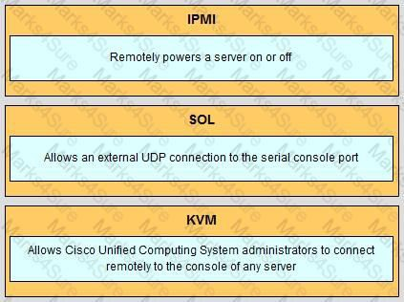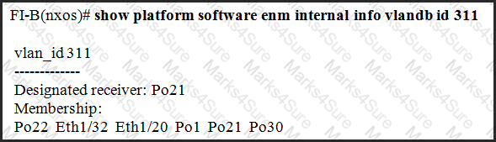

Question #:150 - (Exam Topic 2)

Refer to the exhibit.

Which two statements about the fabric interconnect are true? (Choose two.)

1. The fabric interconnect forwards all broadcast packets on VLAN 311 out of each interface listed in the Membership.
2. The fabric interconnect forwards broadcasts on VLAN 311 only when they are received on Po21.
3. Without any changes to the switch, eth 1/32 could become the designated receiver for VLAN 311.
4. All multicast traffic from a blade on VLAN 311 goes out of Po21.
5. IGMP join packets from blades on VLAN 311 goes out Po21.

### Answer: B E

Question #:151 - (Exam Topic 2)